**UNPROMPTED INSIGHTS: EXPLORING EMPLOYEE PERSPECTIVES ON WORKPLACE HEALTH AND WELLBEING**

C.GHOSN, C. CANDIDO, G. WARREN-MYERS

The University of Melbourne

# Abstract

Health and well-being in the workplace have gained prominence in recent years. However, the value employees place on workplace health and well-being remains understudied. This paper explores the importance of health and well-being from the employee's perspective using voluntary job reviews from Australian IT companies. Specifically, it examines a substantial dataset of 1697 job reviews from the Glassdoor database (2019-2022), focusing on reviews mentioning "health" and "well-being" in comparison to other types of workplace complaints. Considering the whole dataset 5,18% of the reviews are related to “health” and “well-being”, offering insights into employees’ views and value on implementing these strategies in the workplace. Findings also suggest that benefits, organizational culture, leadership, flexible ways of working and food provided by the company were associated with the perception of health and well-being experience and perception of employees. Organisations can leverage these insights to improve their strategies when providing health and well-being strategies in the workplace.

Keywords: health and well-being, Australian offices, Glassdoor, human perception, workplaces

# INTRODUCTION

In workplaces, research has shown that strategies focused on employees’ health and well-being can impact their overall health (Colenberg et al., 2021, 2021; Danielsson and Bodin, 2010; De Croon et al., 2005). Employees account for the largest portion of business operating costs, and a marginal improvement in their health and well-being can potentially generate considerable value for the organizations (Allen and Macomber, 2020; World Green Building Council (WGBC), 2014). In Australia, the aggregate cost to businesses from ill health and absenteeism is estimated at AUS 7 billion per year (Medibank Private, 2005). By fostering a workplace environment that supports employee’s health and wellbeing, organisations can not only attract top talent but also retains their existing work and enhance their productivity. Therefore, understanding employees' needs and perceptions of health and well-being are crucial to organizations.

Collecting and understanding employees' feedback is a valuable source of information (Peretti and Schiavon, 2011) for improving health and well-being in the workplace. Surveys have been consistently employed as a practice to gather subjective data from employees in workspaces (Li et al., 2018; Peretti and Schiavon, 2011). Surveys have evolved from paper-based to online convenience, streamlining the process and allowing a larger sample size, and it usually comprises closed-ended questions linked to a specific topic and response scales (e.g. perceived health, satisfaction, and productivity). More recently, technological progress and the role of ‘reviews’ on services and products, has translated to the workplace, resulting in enhanced data collection from workplace employees, adding unprompted feedback as a source of understanding employees' views of the workplace by incorporating data sourced from online platforms. As a result, a large sample size of unsolicited reviews from employees about the workplace can potentially offer a comprehensive understanding of their perceptions of health and well-being in the workplace. These unsolicited reviews are usually voluntarily posted by employees without any categorical limitations or incentives, offering an opportunity to better explore unprompted feedback from a wide range of topics. Additionally, the open-ended nature of online job reviews further assists in gathering a substantial number of responses that would prove demanding, costly, and time-consuming using traditional surveys.

The analysis of online reviews websites has the potential to offer invaluable insights for organisations and investors alike. Research using online reviews can be found to be applied in many domains, including the analysis of Indoor Environmental Quality (IEQ) from the hospitality sector (Ma et al., 2023; Qi et al., 2017; Villeneuve and O’Brien, 2020; Zhang et al., 2023b, 2023a), and from a wide range of offices (Chinazzo, 2021), where results can potentially enhance user’s and workers satisfaction, leading to increased returns to organisations. Additionally, online job reviews have been used to analyse employees’ sentiment that can potentially impact an organization’s financial outcome (Feng, 2023). Website rankings also offer meaningful information for stakeholders, assisting on identifying high-performance organisations (Filbeck and Zhao, 2023). When it comes to the corporate offices, platforms with anonymised job reviews such as Glassdoor.com and Indeed.com has been used to explore employees’ feedback from employers on many domains, helping shape and understand the organisational and physical corporate environment (Chandra and De Choudhury, 2023; Chen et al., 2023; Chinazzo, 2021; Dabirian et al., 2017; Das Swain et al., 2020; Feng, 2023; Filbeck and Zhao, 2023; Hope et al., 2021). This becomes an important channel to understand topics that are of relevance to these in the marketplace and therefore relevant to organisations when it comes to talent attraction and retention. Recent findings shows that these platforms can act as virtual representation of offline communities (Das Swain et al., 2020), unveiling their practices, including organisational culture aspects (Chandra and De Choudhury, 2023; Das Swain et al., 2020), and how it can significantly influence the individual performance in the workplace (Das Swain et al., 2020) and remote working (Chandra and De Choudhury, 2023).

Organisational culture attributes such as a responsive management, work-life balance, compensations and benefits (Chandra and De Choudhury, 2023; Dabirian et al., 2017; Moro et al., 2021), opportunities for professional developments (Dabirian et al., 2017), nurturing employees interest (Chandra and De Choudhury, 2023) and attention to team work (Moro et al., 2021), are highly valued by employees, contributing to a positive environment and a job satisfaction (Moro et al., 2021). Decisions to implement remote-working was found to be associated with improved work-life balance policies (Chandra and De Choudhury, 2023). Work exhaustion was found to be the main source for employees’ job dissatisfaction (Moro et al., 2021). Additionally, to create a healthy workplace, organisations also need to address factors as diversity, equity, and inclusion, and avoid unethical behaviour (Chandra and De Choudhury, 2023), as workplaces with smaller gender gaps in work-life balance satisfaction are associated with better performance (Chen et al., 2023). These findings demonstrate how organisational factors can potentially impact employee’s perception and influence their performance within the organisation.

Few studies have utilized Glassdoor data to evaluate the physical environment of offices. An IEQ focused study revealed that reviews mentioning IEQ complaint are significantly more negative, constituting 0.91% of total reviews (Chinazzo, 2021). Key concerns include thermal comfort, acoustics, and indoor air quality (Chinazzo, 2021). Finally, through these voluntary online reviews, organisation gain crucial insights into employees’ needs and perceptions, allowing them to enhance their organisational and physical environment for attracting and retaining talents, and facilitating well-informed decision-making. At the time this paper was written no study was found on Scopus that has used Glassdoor database to evaluate the importance of health and wellbeing from the employees’ perspective.

To fill up this gap, and to better understand the context of which employees’ feedback include health and well-being in the workplace, this research proposes an innovative method consisting of analysing public job review data from the Glassdoor website. Glassdoor is a job and recruiting website currently holding more than 115M reviews, of 2.3M companies across 20 countries (Glassdoor, Inc., 2023). Therefore, this study aims to explore the importance of health and well-being to the occupants using voluntary and unbiased feedback from a variety of occupants in many Australian offices workspaces by analysing job reviews posted on Glassdoor database from 2019 to 2022. Specifically, this study aims at identifying firstly, the percentage of reviews containing health’ and ‘well-being’ in online job reviews, and secondly, the context of which health and well-being is being mentioned in these reviews.

# METHODOLOGY

The data collection process comprised the scrapping of data from Glassdoor.com, focusing on Australian office workspaces between the time periods 2019 and 2020. Scraping data from sites such as Glassdoor.com, Booking.com, and Google Reviews have gained popularity over the last decade due to the richness of content and opportunities to analyse data that is readily available online (Chandra and De Choudhury, 2023; Chen et al., 2023; Chinazzo, 2021; Dabirian et al., 2017; Feng, 2023; Filbeck and Zhao, 2023; Ma et al., 2023; Moro et al., 2021; Qi et al., 2017; Villeneuve and O’Brien, 2020; Zhang et al., 2023b, 2023a). For this study, web scrapping scripts were employed to extract employees’ reviews of 17 Australian tech companies from Glassdoor, accounting for 1697 job reviews from 2019-2022. Similar techniques of analysis have been used by other authors (Chandra and De Choudhury, 2023; Chen et al., 2023; Chinazzo, 2021; Feng, 2023; Filbeck and Zhao, 2023).

Using Excel, basic descriptive methods were used to identify the number and percentage of reviews mentioning “health” and “well-being”, the location of job reviews within Australia, and the main job positions mentioning “health” and “well-being”. Following this, NVivo 12 was used to perform the qualitative textual analysis technique for each job review mentioning “health” and/or “well-being”, aiming at understanding the context of which health and well-being is mentioned by employees. Figure 1 illustrate the method for the content analysis using NVivo. Two predefined group of analysis were created, namely (i) Organizational Environment, and (ii) Physical Environment. Based on the literature, these two main elements can be highlighted as the main drivers of a healthier workspace (Flynn et al., 2018), and comprises Level 1 of this analysis. Through an inductive coding, significant patterns and recurring topics in the reviews were identified and grouped under specific codes. These codes were systematically mapped onto relevant sections of the text, creating a structured framework to facilitate subsequent analysis of each review. (Figure 1). Level two aims at identifying the main topics in each review (e.g. benefits provided by the company). When applicable, level three identified segments in each of the topic (e.g. gym membership as a benefit provided by the company), and level four identified if the review in question has a positive or negative evaluation.

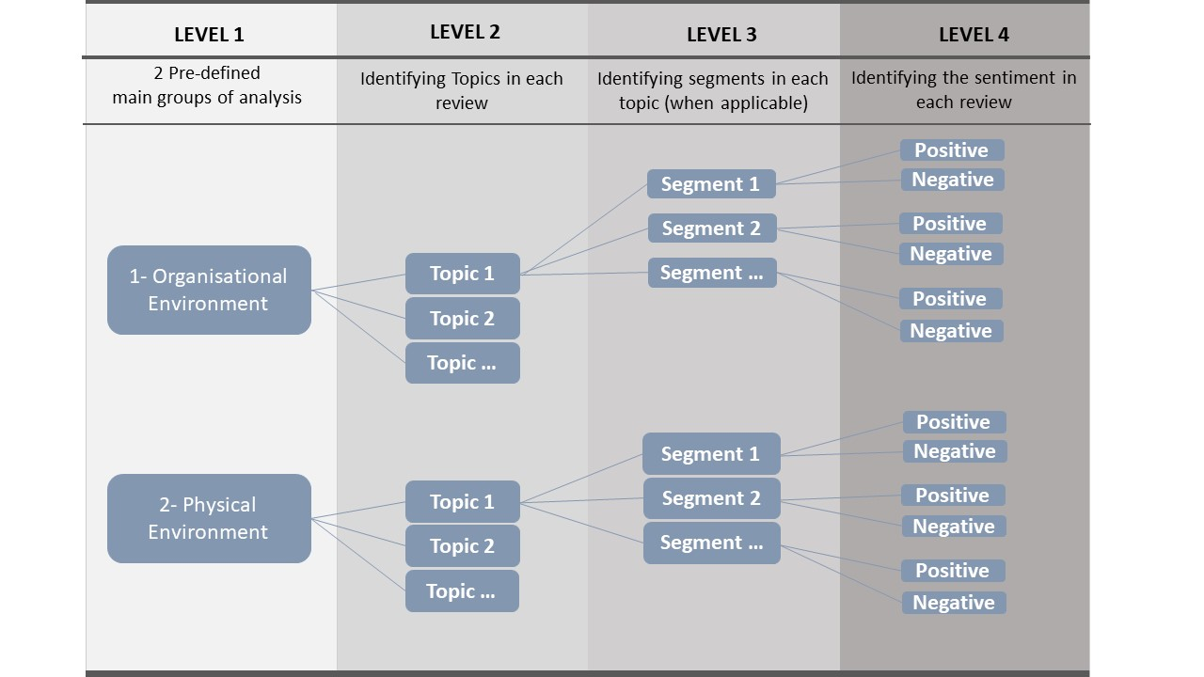

**Figure 1: Levels of the qualitative analysis of the reviews**

# Results

## Summary statistics

The majority of the reviews were located in Sydney (78.79%) and Melbourne (15.97%). Figure 2 illustrate the location of the scraped reviews extracted from the data collection process. The uneven distribution of the reviews is most likely because these two cities host a larger workforce population in Australia.

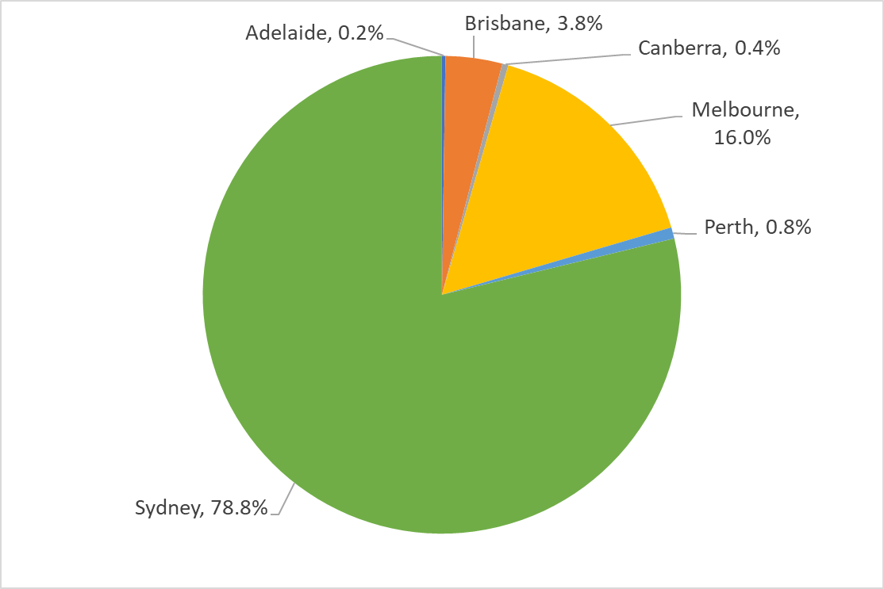

**Figure 2: Percentage of reviews per cities.**

A word frequency analysis was performed with all 1697 reviews to provide an initial understanding of what the key review content comprised. The analysis provides a snapshot of the top 50 results shown in the world cloud below (Figure 3). The findings indicates that employees from Australian tech companies brought up discussion related to culture, people and team, benefits, management and leadership, opportunities and growth, office, environment, flexibility, and balance. This analysis provides an initial understanding of core themes mentioned in the Glassdoor reviews. The subsequent analysis is focusing on the core themes of the paper around ‘health and well-being’.

**Figure 3: Word frequency analysis of reviews.**

## Health and well-being number of reviews.

Out of the 1,697 reviews, a total of 88 reviews were identified as mentioning “health”, and/or “well-being”. Altogether, this constitutes a total of 5.18% of all reviews. Figure 4 shows the breakdown of positive (pos) and negative (cons) reviews for each of the keyword “health” and “well-being”. The analysis found that positives reviews on “health” are the most predominant ones, and that the negative (cons) reviews on “well-being” hold the smallest number of reviews. Figure 5 shows the trend of the number of reviews of the whole dataset over the time period studied. Figure 6 shows the trend of health and well-being in the analysed period. It indicates an increase in the number of reviews over the years, with a peak number of reviews in 2022. The smallest number of reviews was in 2020 and is due to the COVID-19 lockdowns.

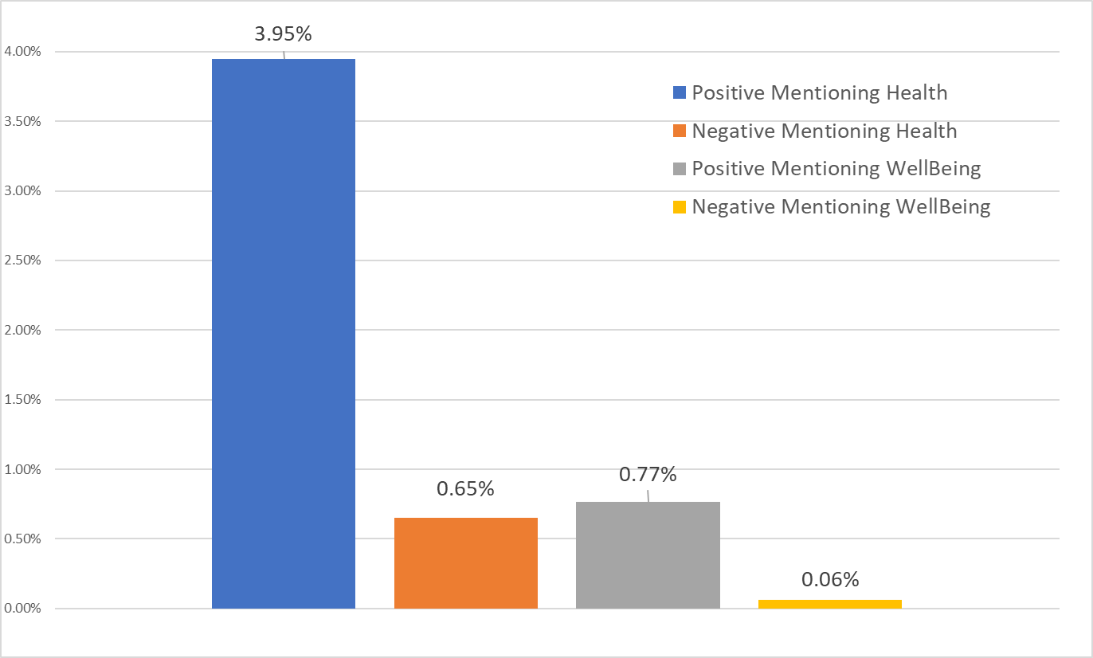

**Figure 4: Percentage of reviews mentioning "health" and "well-being".**

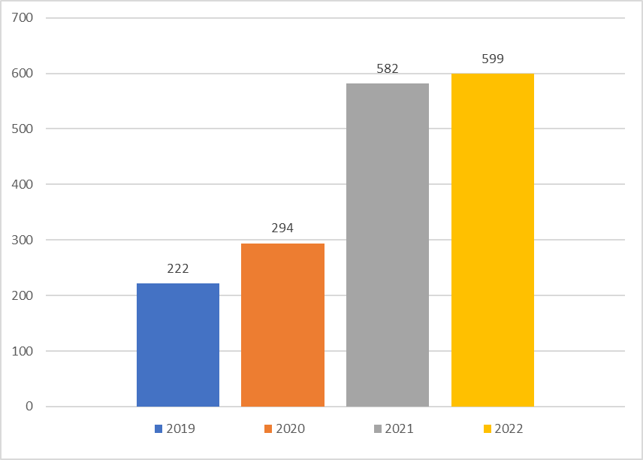

**Figure 5: Total number of reviews per year, whole dataset.**

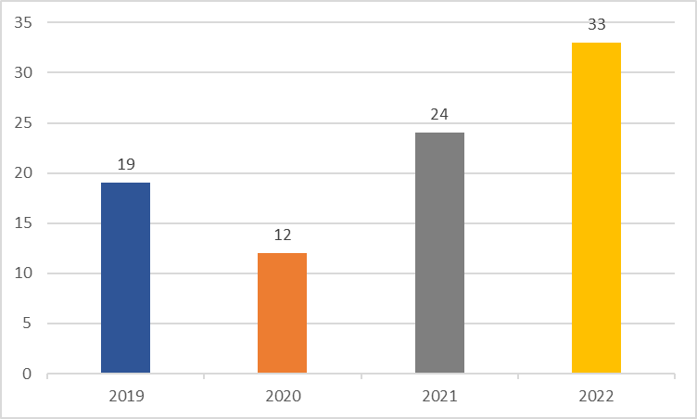

**Figure 6: Number of reviews for health and well-being only.**

In exploring the data further, the 88 reviews were categorised into job positions that comprised similar roles, and were grouped into eight distinct categories as illustrated in Figure 7. “Others”, refers to job positions classified as ‘Anonymous’, or job position characterized by a limited number of online reviews. Engineers have posted most of the reviews mentioning “health” and/or “well-being”, followed by “Others” position. Managers, which encompasses a leadership role, along with Account Executives, have similar percentage of reviews. Altogether, “Account Manager”, “Engineers”, “Managers” and “Others” account for 88,64% of all reviews mentioning “health” and/or “well-being”.

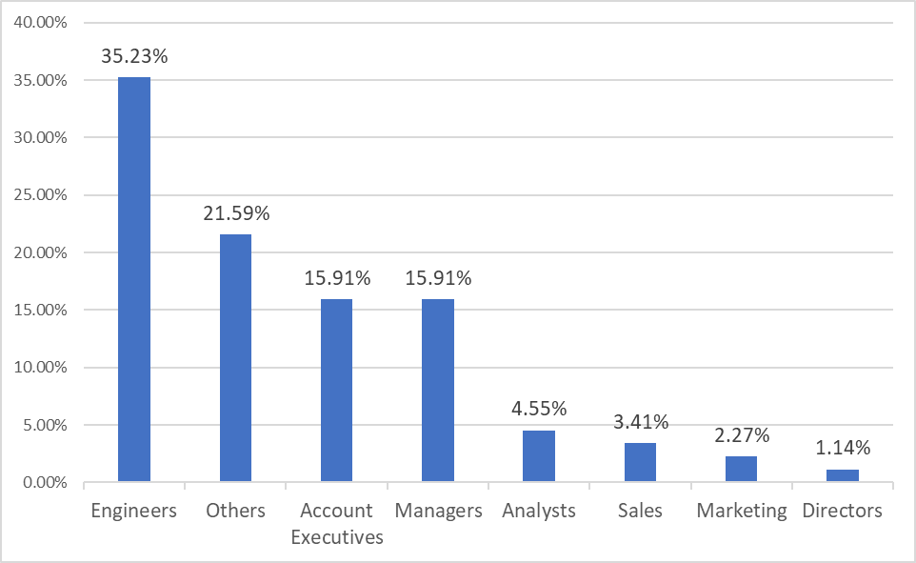

**Figure 7: Percentage of reviews, pros, and cons, mentioning health and well-being, per work position.**

## Qualitative analysis of the reviews

The total number of 88 reviews that mentioned “health” and/or “well-being” where systematically analysed as shown in Figure 1. For each of the two main groups (level 1), codes were created to systematically map the topics (level 2), the segments (level 3) and the sentiment analysis (level 4) of each review. The Organizational Environment group covers the majority of the reviews, revealing up to 10 topics, including:

1. “Benefits”, which covers all kind of benefits provided by the company, such as health insurance, gym membership and others.
2. “Organizational culture”, referring to the shared values, beliefs and practices influencing employees’ interactions within the workplace.
3. “Leadership & Management”, mostly depicting how leadership positions can impact employee’s health, well-being and productivity.
4. “Working arrangements and flexibility”, which includes how different ways of working can influence employee’s perception of the company, productivity, health and well-being.
5. “Personal career growth”, illustrating how the company values, policies and programs influences employee’s personal and professional growth.
6. “Food”, referring to the type of food and paid meals provided by the company.
7. “Mental health”, understanding if and how the company cares about employee’s mental health.
8. “Work life balance”, which relates to of how the company balances employee’s responsibilities and personal well-being.
9. “Working environment”, referring to the physical, cultural, and interpersonal conditions in which employees work and collaborate.
10. Diversity, equity and Inclusion (DEI), which demonstrate if the company have implemented DEI strategies and how it can influence employee’s health and well-being.

The Physical Environment group has the fewer number of references, revealing up to 4 main topics:

1. “Office in general”, including general comments about the office space, aesthetics, and cleaning.
2. “Existence of office”, where employees discuss the benefits of having an office or not.
3. “Office layout”, mostly covering how the office layout impacts employee’s productivity.
4. “Office location”, with employees reporting the benefits (or not) of the office location within the city.

**Table 1: Results for all the level of analysis of the reviews.**



This means that whenever “health” and/or “well/being” were mentioned, these topics (and their own segments) were also raised, and this could be as a positive and/or negative aspects of the review. More importantly, it shows the context in which “health” and/or “well-being” is being mentioned. Table 1 illustrates all the topics (level 2), segments (level 3) and number of sentiment analysis (level 4) for the whole dataset. The number of references on the last column refers to the number of times that this topic was mentioned in the whole dataset. The first five topics shown on Table 1 (“Benefits”, “Organizational culture”, “Leadership & management”, “Working arrangements flexibility” and “Food”) account for up to 70% of the references, and thus was used for the following qualitative analysis of the reviews.

Table 2 illustrate the number of references between job position and all the five most relevant topics generated for this study. “Benefits” is the topic mostly raised by all job positions. “Organizational culture” was mostly cited by “Engineers”. However, “Managers” have frequently brought up the same topic. “Leadership Management” was essentially cited by “Account Executives”, “Engineers” and “Others”. “Working arrangements flexibility” have shown to be relevant mainly for “Engineers”, who usually have more flexibility in terms of ways of working within the tech industry, and “Managers”. Lastly, the number of references for “Food” relates to positions such as “Account executive”, “Engineer”, and “Others”. “Food” is mostly related to the availability of healthy snacks, paid lunch, and coffee within the office space.

**Table 2: Number of references by job positions.**



### Qualitative analysis of the main reviews

Reviews related to the five most cited topics were individually analysed. Table 3 outlines the reviews referring to positive and negative evaluation of the five main topics. “Benefits” is the topic with more positive reviews from all the data set. When examining in more detail, the keyword “Health” was mostly cited in the context of health insurance, rather than reference to the office or workplace environment. Other aspects noted within their part of the review, also mentioned other benefits related to “Education” opportunities, access to “Gym Memberships”, different kinds of “Leave”, such as parental or personal leave, “Volunteers opportunities” and access to “Well-being allowance”, which refers to paid recharge days for personal wellness, well-being and/or mental health services covered by the company. Positive reviews on “Benefits” also include comments on great “Leadership management”, “Organizational culture”, “Working environment”, “DEI”, and “Working arrangements flexibility”. Although very low, negatives reviews on “Benefits” usually covered the lack of benefits provided by the company, such as access to gym membership and health insurance.

“Organizational culture” is the second most cited topic, with 21 positive and 19 negative reviews. Positive reviews shows that a strong organizational culture can be linked to “Benefits” that includes “Mental health” (such as well-being allowance and/or recharge days), “Working arrangements flexibility” along with home office budget and “Leadership & management”. Negative reviews on “Organizational culture” shows a tendency of linking “Organizational culture” to “Work life balance”, “Mental health” along with stress and poor “Leadership & management”.

“Leadership & management”, is the third most cited topic, and the first with the highest number of negative reviews. Reviews often shows that a negative sentiment towards the leadership also lead to complaints in the “Organizational culture”, “Mental health” along with well-being, “Working arrangements flexibility”, and “DEI”. On the other hand, “Leadership & management” has a similar number of positive reviews, when compared to the negative ones. Positive reviews on “Leadership Management” shows that it can impact employee’ turnover, well-being, “Mental health”, “Work life balance”, “Working arrangements flexibility”, and a series of “Benefits” provided by the company. It was also identified that some reviews highlighted employee’s turnover and organizations outcomes.

Only two negative reviews were found under the “Working arrangements flexibility” topic, and it relates to the non-flexible arrangements to be able to work from overseas, along with reviews which highlights the impact of face-to-face interactions and employee’s morale during COVID_19 lockdowns. Positive reviews on “Working arrangements flexibility” is the second topic with positive reviews in the whole dataset. Reviews shows that flexible work arrangements were mentioned along with themes related to “Benefits”, “Office in general”, “Mental health”, “DEI”, well-being and the ownership over employee’s time management.

The last topic refers to “Food” that is usually provided (or not) within the office environment. Negative reviews were mostly on the lack of food or snacks provided by the company. However, positive reviews could be divided into general snacks, drinks and meals and healthy food options provided in the office space. Although understood as a “Benefit”, some reviews highlighted the importance of having a healthy food option available.

**Table 3: Reviews referring to positive and negative evaluation of the five main topics.**



# DISCUSSION

The importance of health and well-being in the workplace has grown in recent years. Understanding employees’ perception of what constitutes health and well-being within the workplace can effectively help organizations provide a better working experience along with improving organizational outcomes. This study offers insights into the context of which employees’ feedback include health and well-being in the workplace from Glassdoor review posts provided by workers of tech companies across Australia. Among 1697 reviews, only 5.18% mentioned “health” and/or “well-being” in different contexts. Studies using similar methodology found even lower percentage when analysing complaints on IEQ in workspaces (Chinazzo, 2021) and hospitality sector (Qi et al., 2017). These results may be attributed to the limitations of this study, defined by the small number of reviews, as well as a restricted set of keywords (only two, being “health” and ‘well-being”) focused on the evaluation of reviews. Studies analysing online reviews usually comprise a larger dataset and/or of a set of custom vocabulary associated with the issue being analysed (Chinazzo, 2021; Moro et al., 2021; Qi et al., 2017; Villeneuve and O’Brien, 2020).

Among the reviewers, Engineers emerged as the primary group of job position frequently referencing “health” and/or “well-being” in their reviews, followed by managers, account executives and others. This finding highlights the importance of “health” and “well-being” in a variety of professional roles, which is similar to what was found in other studies (Chinazzo, 2021).

The qualitative analysis comprised the deeper analysis of how “health” and “well-being” were mentioned, categorized in two main distinct groups: (i) Organizational Environment, and (ii) Physical Environment. Even though the Organizational and Physical environment are strong components for developing and implementing health and well-being strategies within the workplace (Allen and Macomber, 2020; Colenberg et al., 2021; Colenberg and Jylhä, 2021; Flynn et al., 2018), findings for this study shows that “health” and well-being” was mostly cited in the context of the Organizational environment group, reinforcing the need to develop studies focused on the physical environment of offices. The lower number of reviews related to the Physical environment can also be related to the limitations of the study regarding the smaller dataset and limited number of key words used to analyse the reviews.

Up to 70% of all the topics revealed were found to be related to “Benefits,” “Organizational Culture,” “Leadership Management,” “Working Arrangements Flexibility,” and “Food,”, helping understand the context in which health and well-being discussions take place. The topic related to “Benefits” was highly scored since the word “health” was mostly cited in the context of health insurance. Positive reviews predominantly highlight “Benefits” provided by the company, such as health insurance, education, gym membership, volunteer opportunities, well-being allowance and paid leaves. Within the context of “Benefits”, “Well-being allowance” and “Volunteer opportunities” were the two segments most highly mentioned. This is aligned with some studies highlighting the importance of benefits and compensation for employees satisfaction (Chandra and De Choudhury, 2023; Dabirian et al., 2017). Additionally, providing well-being allowance, which is related to paid recharged days and/or mental health services, can help support early diagnosis of mental health issues (World Health Organization, 2013). Volunteering opportunities were positively linked to higher self-rated health, self-esteem, educational and occupational achievement and functional ability (Wilson, 2000).

Findings from this research also shows that topics related to strong “Organizational culture” and effective “Leadership & management” were often tied to positive experiences in mental health and well-being. Aligned with other researches (Chandra and De Choudhury, 2023; Dabirian et al., 2017; Das Swain et al., 2020; Hope et al., 2021; Moro et al., 2021), reviews also indicated that a strong organizational culture and effective leadership management positively impact employees' overall experiences.. Moro et al., 2021, found that management issues and workload are crucial to improve teamwork and work balance, and subsequently increase employee satisfaction. Negative reviews from this study shed light on challenges, including toxic work cultures, poor leadership, and limited flexibility, which in turn can lead to employee stress and poor mental health. Similarly, studies have found that social elements of work, a strong and supportive leadership and managements, work life balance (Dabirian et al., 2017), and a strong organisational culture (Hope et al., 2021)are crucial elements for employees.

The topic related to “Working arrangements flexibility” was the second highest topic mentioned by employees, positively mentioning the possibility to work from home along with the challenges of face-to-face interactions during lockdowns. This was also found in recent studies or working arrangement and flexibility during the pandemic (Marzban et al., 2021). Lastly, “Food” availability was also frequently mentioned and positively evaluated, with part of the reviews even mentioning the availability of healthy food in the workplace. This suggests an employee’s awareness of a healthy diet and its impact on their health. Research have shown that increasing healthy food option in the workplace can also improve the consumption of healthy food at home (Schwartz et al., 2017).

# CONCLUSION

Analysis provided in this paper provides insights into the perceptions of employees regarding health and well-being within their workplace. The results show that “health” and “well-being” was mostly cited in the context of the Organizational environment group, emphasizing the significance of “Benefits”, “Organizational culture”, “Leadership & management”, “Flexible working arrangements”, and “Food” offerings in shaping employee experiences on health and well-being in the workplace. This implies that employees place great emphasis to these factors when considering their health and well-being in the workplace. Job position has an influence on the topics discussed, with Engineers posting the highest number of reviews in this dataset. The topic related to “Benefits” have received the highest number of positive reviews, whereas “Leadership & management” had the highest number of negative reviews. This suggest that employee’s perception of leadership and management can potentially influence their discussion about health and well-being. Organisations can leverage these insights to enhance their strategies for fostering a positive and healthy workplace environment that resonates with employees' needs and perceptions, thereby also optimizing their returns.

Further studies using a larger dataset and a strong set of customized vocabulary related to health and well-being should be carried out to provided deeper understanding of the perception of employees regarding health and well-being in the workplace. Limitations of this study can be linked to the small number of reviews within the dataset, and the use of only two keywords ("health" and "well-being"). Given the complex and multi-dimensional nature of workplace health and well-being, employing a more comprehensive set of keywords aligned with the context can have the potential to better illustrate employees' perceptions, as main findings from this study highlights the importance of leadership and management and other organizational initiatives such as benefits and leadership management. Although playing an important role on leveraging the health and well-being aspects of a workplace, the physical environment component had lower mentions in this study. Nevertheless, this study serves as a preliminary exploration, suggesting a potential experimental design for investigating larger datasets with a wide range of substantial keywords that can represent all the variables that constitute health and well-being in the workplace.

# References

Allen, J.G., Macomber, J.D., 2020. Healthy Buildings: How Indoor Spaces Drive Performance and Productivity, Healthy Buildings. Harvard University Press. https://doi.org/10.4159/9780674246102

Chandra, M., De Choudhury, M., 2023. What Makes Some Workplaces More Favorable to Remote Work? Unpacking Employee Experiences During COVID-19 Via Glassdoor, in: Proceedings of the 15th ACM Web Science Conference 2023. Presented at the WebSci ’23: 15th ACM Web Science Conference 2023, ACM, Austin TX USA, pp. 312–323. https://doi.org/10.1145/3578503.3583602

Chen, J., Jing, C., Keasey, K., Lim, I., Xu, B., 2023. Gender, Workplace Preferences, and Firm Performance: Looking Through the Glass Door. European Financial Management. https://doi.org/10.1111/eufm.12421

Chinazzo, G., 2021. Investigating the indoor environmental quality of different workplaces through web-scraping and text-mining of Glassdoor reviews. Building Research & Information 49, 695–713. https://doi.org/10.1080/09613218.2021.1908879

Colenberg, S., Jylhä, T., 2021. Identifying interior design strategies for healthy workplaces – a literature review. Journal of Corporate Real Estate. https://doi.org/10.1108/JCRE-12-2020-0068

Colenberg, S., Jylhä, T., Arkesteijn, M., 2021. The relationship between interior office space and employee health and well-being–a literature review. Building Research and Information 49, 352–366. https://doi.org/10.1080/09613218.2019.1710098

Dabirian, A., Kietzmann, J., Diba, H., 2017. A great place to work!? Understanding crowdsourced employer branding. Business Horizons 60, 197–205. https://doi.org/10.1016/j.bushor.2016.11.005

Danielsson, C.B., Bodin, L., 2010. “Office type in relation to health, well-being, and job satisfaction among employees”: Erratum. Environment and Behavior 42, 887–887. https://doi.org/10.1177/0013916510382750

Das Swain, V., Saha, K., Reddy, M.D., Rajvanshy, H., Abowd, G.D., De Choudhury, M., 2020. Modeling Organizational Culture with Workplace Experiences Shared on Glassdoor, in: Conference on Human Factors in Computing Systems - Proceedings. Association for Computing Machinery. https://doi.org/10.1145/3313831.3376793

De Croon, E., Sluiter, J., Kuijer, P.P., Frings-Dresen, M., 2005. The effect of office concepts on worker health and performance: a systematic review of the literature. Ergonomics 48, 119–134. https://doi.org/10.1080/00140130512331319409

Feng, S., 2023. Job satisfaction, management sentiment, and financial performance: Text analysis with job reviews from indeed.com. International Journal of Information Management Data Insights 3, 100155. https://doi.org/10.1016/j.jjimei.2023.100155

Filbeck, G., Zhao, X., 2023. Glassdoor best places to work: how do they work for shareholders? SEF 40, 1–23. https://doi.org/10.1108/SEF-11-2021-0510

Flynn, J.P., Gascon, G., Doyle, S., Matson Koffman, D.M., Saringer, C., Grossmeier, J., Tivnan, V., Terry, P., 2018. Supporting a Culture of Health in the Workplace: A Review of Evidence-Based Elements. American Journal of Health Promotion 32, 1755–1788. https://doi.org/10.1177/0890117118761887

Glassdoor, Inc., 2023. About Us - Glassdoor [WWW Document]. URL https://www.glassdoor.com/about/ (accessed 2.18.23).

Hope, O.-K., Li, C., Lin, A.-P., Rabier, M., 2021. Happy analysts. Accounting, Organizations and Society 90. https://doi.org/10.1016/j.aos.2020.101199

Li, P., Froese, T.M., Brager, G., 2018. Post-occupancy evaluation: State-of-the-art analysis and state-of-the-practice review. Building and Environment 133, 187–202. https://doi.org/10.1016/j.buildenv.2018.02.024

Ma, N., Zhang, Q., Murai, F., Braham, W.W., Samuelson, H.W., 2023. Learning building occupants’ indoor environmental quality complaints and dissatisfaction from text-mining Booking.com reviews in the United States. Building and Environment 237, 110319. https://doi.org/10.1016/j.buildenv.2023.110319

Marzban, S., Durakovic, I., Candido, C., Mackey, M., 2021. Learning to work from home: experience of Australian workers and organizational representatives during the first Covid-19 lockdowns. JCRE 23, 203–222. https://doi.org/10.1108/JCRE-10-2020-0049

Medibank Private, 2005. The Health of Australia’s Workforce.

Moro, S., Ramos, R.F., Rita, P., 2021. What drives job satisfaction in IT companies? International Journal of Productivity and Performance Management 70, 391–407. https://doi.org/10.1108/IJPPM-03-2019-0124

Peretti, C., Schiavon, S., 2011. Indoor environmental quality surveys. A brief literature review.

Qi, M., Li, X., Zhu, E., Shi, Y., 2017. Evaluation of perceived indoor environmental quality of five-star hotels in China: An application of online review analysis. Building and Environment 111, 1–9. https://doi.org/10.1016/j.buildenv.2016.09.027

Schwartz, M.B., Just, D.R., Chriqui, J.F., Ammerman, A.S., 2017. Appetite self-regulation: Environmental and policy influences on eating behaviors: Environmental and Policy Influences on Eating Behaviors. Obesity 25, S26–S38. https://doi.org/10.1002/oby.21770

Villeneuve, H., O’Brien, W., 2020. Listen to the guests: Text-mining Airbnb reviews to explore indoor environmental quality. Building and Environment 169, 106555. https://doi.org/10.1016/j.buildenv.2019.106555

Wilson, J., 2000. Volunteering. Annual Review of Sociology 26, 215–240.

World Green Building Council (WGBC), 2014. Health, Wellbeing & Productivity in Offices The next chapter for green building. WGBC Report: London, UK.

World Health Organization, 2013. Mental health action plan 2013-2020, Plan d’action global pour la santé mentale 2013-2020. World Health Organization, Geneva.

Zhang, F., Seshadri, K., Pattupogula, D.V.P., Chandana, B., Liu, S., 2023a. Indoor environmental quality satisfaction in Australian hotels and serviced apartments. E3S Web of Conf. 396, 01055. https://doi.org/10.1051/e3sconf/202339601055

Zhang, F., Seshadri, K., Pattupogula, V.P.D., Badrinath, C., Liu, S., 2023b. Visitors’ satisfaction towards indoor environmental quality in Australian hotels and serviced apartments. Building and Environment 244, 110819. https://doi.org/10.1016/j.buildenv.2023.110819