ARE INVESTORS BEING INCENTIVISED TO EXIT RESIDENTIAL INVESTMENT?
Neville Hurst¹, Jarrad Hurst²
1 RMIT University, Melbourne, Australia
2 London Southbank University London, UK

ABSTRACT
The provision of rental accommodation is a critical component of the housing system and prices of such accommodation tend to follow the principles of supply and demand. In the Australian context, and in particular, Victoria, Australia’s most densely populated state, the supply of suitable rental accommodation has reached critically low levels resulting in spiralling rent increases creating further difficulties for the most vulnerable. Although the provision of private rental accommodation typically comes from smaller “mum and dad” investors the state government recently introduced an extensive list of changes to local tenancy regulations and taxation proposals that is arguably discouraging investment in housing. Such an outcome would exacerbate supply, further compounding rental prices. In addition, the state government is investigating options of creating measures to accelerate the retrofitting of energy efficient measures into existing housing stock. This is currently happening in the UK with the introduction of Minimum Efficiency Energy Standards (MEES) for rental housing stock.

This paper presents a critical review of the current rental crisis that is occurring in Victoria, Australia. It does this by providing a discussion of the reported impacts of the regulatory changes imposed upon landlords as well as potential impacts of taxation laws. It further provides a pragmatic discussion of house energy efficiency standards relating to rental properties and then synthesises these with views expressed by real estate agents to evaluate the potential impact upon investment in the housing market. With much of the data sourced from literature and real estate agents, the aim of this paper is to create a research agenda to explore the potential affects of regulatory imposts to an important social need.

Keywords: Residential tenancy, Real estate agents, Land tax, Energy efficiency

INTRODUCTION
Housing is a fundamental requirement for human existence and has become one of the more contentious issues globally. In many countries, private rental markets play a significant role in the provision of housing. Generally, individuals invest in residential real estate with the expectations of financial gain over time. Like all investments, rewards for investors in residential markets are subject to market forces, which are in turn are influenced by economic and other extant settings. Investors interpret these conditions to decide whether to enter, exit, or retain their investment status quo depending upon their understanding of the potential returns. Investors are typically pragmatic and commit capital with the expectation of receiving future financial reward. Consequently, they are sensitive to real or perceived impediments to expected benefits. However, the relationship between landlord and tenant can be a tenuous one with landlords inherently having the upper hand. To balance this, many countries have legal frameworks around the letting of houses. This paper examines the interrelationships between pertinent tax and government regulations upon investors in the Australian state of Victoria.
The extent and enforcement of existing laws regulating behaviours between landlords and tenants generally depends upon local customs and maturity of the legal system. The diversity of individual need/expectations regarding housing has the potential to create a complex array of laws and regulations. These edicts are sometimes at odds with each other. Together, they can conceivably create an environment of pessimism for investors.
In Victoria, residential investors provide approximately 28.5% of housing stock (ABS 2021a) and are subject to a range of regulations and requirements governing owner/tenant legal relationships and behaviours, accommodation standards, and potentially, minimum dwelling energy efficiency performance. An array of taxation laws also impact investors.
Understandably, the amount of accommodation provided by investors is impacted by the complex antithesis of regulation and tax balanced against incentivisation for investment within a capitalist market. This creates a delicate balance for government to manage if investors are to remain interested in housing as an investment.
This article does not attempt to resolve these issues, nor does it provide extensive empirical evidence to demonstrate the scope of the issue. Rather, the article provides critique of existential policies affecting residential tenancies and the potential confounding effect of these regulations may have on the residential rental stock. To do this the article presents an overview of the current Residential Tenants Act (Vic), recently proposed state-based taxation laws, and the mooted introduction of minimum energy performance standards. The final section of the paper provides a summarised discussion and concludes with a recommendation for a research agenda that can inform governments and industry of the potential impacts.

Background of methodology adopted.
This investigation is multifaceted, in that practitioner opinions were sought, and information was gathered from government and similar reliable websites, and data interpreted to form the researchers’ views. In other words, the literature reviewed in essence became the data and therefore, the findings are not absolute in themselves. Rather, they reflect the emergence of a disturbing trend of disincentivising residential property investment in Victoria. To generalise the findings, further, more in-depth, research is required.

THE ISSUES AND REGULATORY RENTAL LANDSCAPE IN VICTORIA

Victoria’s housing landscape
In Victoria around 29.5% of households rent. Of these approximately 25.8% households rent privately and 3.6% in social housing provided by government and/or not for profit organisations (ABS 2021a). This means the government is very dependent upon private investors to support the state’s housing needs. Industry observers, and housing providers alike, agree that Victoria’s rental eco-system is in a perilous state with rents increasing significantly. Greater Melbourne (Victoria’s capital city region) reported an increase in rents of 19.1% over the period June 2022 till June 2023 (SQM Research 2023). In context, it should be noted that this percentage increase is from a low point resulting from the Covid19 pandemic period. Nonetheless, it is an overall increase of 21.3% from June 2020 when recorded rents started to fall due to the pandemic. Over the same period, average salary increases have been typically around 2.5%-3.5%. The pressure such an incongruence places upon renters is obvious.
The reliance of the provision of private rental accommodation by governments is rarely noted in media and voices stressing the plight of tenants are prominent in the debate of housing provision. Investors are often characterised as greedy with headlines such as “Housing crisis warrants vacancy tax on greedy investors.” appearing in media (Sydney Morning Herald, 20 May 2023). Such headlines place pressure on governments to “protect” vulnerable tenants and arguably result in policy that can be counterproductive to supply by disincentivising investors.
The Australian Tax Office (ATO) (2023) states that approximately 2,245,500 Australians, or around 20% of Australian taxpayers own residential property investment. Specific data for Victoria is not available but it is reasonable to assume similar proportionality would apply to this populous state. Table 1 provides a breakdown of the Australian residential investors.

Table 1: Numbers of investment properties held by investors.
Numbers of investment  Property held | Percentage of Australian  investor population
1 | 71.48%
2 | 18.86%
3 | 5.81%
4 | 2.11%
5 | 0.87%
6 or more | 0.89%
Source: Forbes 2023

Less than 1% of investors have 6+ properties and could therefore be considered portfolio investors. Potentially, smaller investor landlords could be considered “vulnerable” to negative changes as their ability to absorb adverse externalities would naturally be lesser than portfolio investors. Nearly 64% investors are aged between 36 and 55, and the average age to pay a mortgage off for homeowners in Australia is 62 years (Mortgage house 2022). It is thus reasonable to believe that many investors are also paying off a mortgage for the house they live in and are therefore sensitive to rental eco-system and negative impacts to the financial viability of the investment. Figure 1 provides details of investor profile by age.
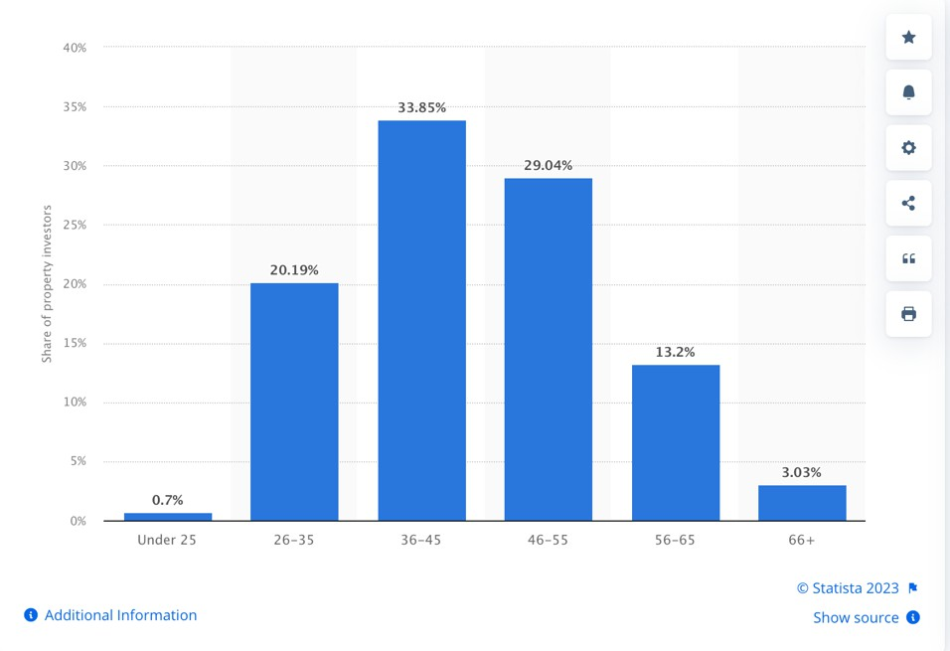

Figure 1: Investor profile by age (Source: Statista 2022)

The next part of this discussion provides a brief overview of three policy areas that are seen as potentially disincentivising investors in Victoria.

Residential tenancy regulation
The relationship between a landlord and tenant is an inherently an unequal one. The objectives of the respective parties innately create a situation where one party is seeking to leverage off the basic need of the other, that is, the need for shelter. The provider of shelter is at an advantage in that they offer shelter to a tenant, who is needing accommodation, for a financial reward. This reward cannot be considered essential in terms of survival, only beneficial. This situation has led societies to develop rules to “re-balance” this unequal relationship. The form and extent to which this is being done varies globally.
When discussing the landlord/tenant relationship in Malaysia, Jalil and Maidin (2021, pg1) notes “…… [the] need to have a specific legislation to regulate the relationship between the landlord and tenant as the development, sustainable and viability of residential tenancies market is largely depending on its enabling factors such as laws, statutes, and regulations.”
Such regulations are generally not simply about the relationship between the parties in a contractual sense. They also embody doctrines and cultural paradigms that embrace social policy, consumer and contract law, anti-discrimination, environmental laws, convention of human rights and so forth (Schmid and Dinse 2013). The difficulty in balancing the reality of the interests of the respective stakeholders to encourage residential investment, while not disadvantaging tenants, is obvious when one evaluates the legal doctrines embodied within the regulations. Governments worldwide appear to struggle in this regard.
The wide-ranging view among economists is that regulation, including rent regulation, has numerous negative effects on housing markets with market-distorting side effects such as misallocation, rental housing shortage and maintenance issues (Jenkins 2009). Over the twentieth century Europe has seen a decline in the supply of private housing with many researchers attributing socially orientated tighter regulation to this, at least in part (for examples see: Haffner, Elsinga and Hoekstra 2008; Whitehead et al 2012). Since then, other researchers have observed an increase in private investor activity that aligned with a political move towards a neo-liberal approach to the housing market; this is not benefiting all strata of society (Van Gent and Hochstenbach 2020). Similar tensions apply in Australia.
Within Victoria, numerous efforts have been made to develop regulation that embodies social expectations of habitation, tenure security and anti-discrimination within the dogma of contractual law and obligations. The extent to which these efforts have successfully achieved this balance remains a moot point and the subject of intense debate when changes are proposed. The authors found no hint of recognition of the need to attract investors into the housing market. It seems that the law makers assume people will invest in residential real estate when able to do so.
Currently, the Residential Tenancies Act (Vic), hereafter referred to as “RTA”, is Victoria’s overarching legislation governing the procedures and behaviours of stakeholders in the provision of residential tenancies. The RTA is extensive and regulates many aspects of the landlord-tenant relationship in a very prescript manner. The RTA has undergone successive iterations since its inception in 1980 and underwent a major re-write in 1997 (Law Library Victoria 2023). The RTA has from time to time been criticised for its bias, weaknesses by both tenant groups and industry bodies, including real estate agents, whose businesses are heavily engaged in the field of rental management. As one would imagine, these criticisms often contradict each other.
The RTA governs items such as mandating lease terms, security bond limits, eviction notice periods, reasons for eviction notice, and habitable standards of accommodation provided. The RTA also encompasses all types of long-term dwellings within its remit (CAV 2023). For example, retirement villages, residential parks such as caravan parks and boarding houses all fall within the governance of the RTA. Without doubt the RTA plays an important role in the protection of vulnerable elements of society, and recent changes included over 130 amendments and additions. Some are operational (administrative) and others having a direct impact on landlords. An objective examination showed changes were aimed at providing tenants greater rights. Of the 130 plus amendments (the specific number is not stated on the CAV website) made to the RTA, only 14 were arguably in favour of the landlord.
Notable changes to RTA in 2021 include (Source: CAV 2023):
- A ban on rental bidding- To remove the practice of encouraging higher offers for rent.
- New rental minimum standards- To ensure rented dwellings offer a minimum standard of habitation, adequate heating for example.
- No eviction without a reason- In response to claims that landlords were evicting tenants for invalid reasons, or simply didn’t like or trust the tenant.
- Allowable minor modifications by renters- To enable tenants to create a more “home like” atmosphere. The CAV website provides an extensive list of as of right, permitted, and excluded modifications.
- Urgent repairs- This provision existed prior to the amendments but now gives the tenant greater rights to organise repairs without landlord permission forwarding costs to the landlord.
It is not the aim of this paper to provide a critical review of the RTA, but rather to place it within context of residential investment and relevance to investors.
While acknowledging the desirability of rental income, investors in Australia typically invest with the primary expectation of capital growth. Net yields are acknowledged as being low, often 2-3% or less. They are also rarely cognisant of the nuances of the RTA and typically rely on real estate agents to manage the property post-acquisition. Therefore, the real estate agent is a rich source of information when seeking to understand views of investors in this sector. However, before discussing the views of agents, it is important to consider another recent government announcement regarding changes to Land Tax laws in Victoria as this change will undoubtably affect investor views.

Land tax
Tax is a necessary burden for the betterment of society. Adam Smith (1776) in his treatise the “Wealth of Nations” argued tax should have four key elements, these are: fairness, certainty, convenience, and efficiency. Regarding land tax, it can only be considered a wealth levy.
Land tax is typically a “broad-based” tax due to its reach and regularity (usually levied annually), as distinct to transaction tax, such as duty paid on land transfer. From an economic perspective, land tax is considered economically efficient (Hughes et al. 2020). From a budgeting perspective, governments would clearly prefer broad-based taxes as they provide greater predictability and many jurisdictions throughout the world typically charge land tax to raise revenue. How this is done varies considerably. On which land the tax applies also varies but in Victoria, land that is the principal place of residence for the owner is exempt. The threshold value for land tax assessment is currently $300,000AUD. The tax is levied against the total value of land owned by a person(s) or legal entity, excluding the principal place of residence.
In a recent state budget announcement, the Victorian government announced it would be reducing the land tax threshold for all properties that were not the owner’s principal place of residence, aka investment properties. The threshold for land tax will be reduced from
$300,000AUD for unimproved land value to $50,000AUD, which encompasses virtually all land in Victoria, other than the most remote. This is a first for any state in Australia. This move attracted considerable push back from numerous industry bodies such as the Real Estate Institute of Victoria.
The reduction of the threshold value was justified as necessary to meet financial burdens created by the recent Covid19 pandemic and would be removed after 10 years when the debt is expected to be paid. Many observers do not anticipate the removal will occur as they believe once a tax is consolidated, it will become the norm. The state government noted the tax could be subject to partial refund from the federal government under Australia’s usual taxation laws. However, not all the funds are recoverable, and this additional impost only serves to reduce what are already low yields for residential investment.
In response to this land tax proposal, the REIV engaged one of the authors to develop a survey to solicit agent experiences regarding investor client intentions. This work was done on behalf of the REIV and not as an independent researcher during 2023. Therefore, ethics considerations were the responsibility of the REIV and data retained by them. The survey was designed to address concerns raised by various stakeholders within the industry and documented by the REIV. REIV senior management provided key questions to be addressed. The developed survey instrument was reviewed by REIV internal research staff, and a final draft agreed upon. The survey sought both quantitative and qualitative responses (n=112).
The number of survey’s distributed is unknown as the REIV performed this role internally and the researchers are not privy to this information. However, the distribution is understood to be around 800 members active in residential property management. Analysis of the qualitative data was thematic and quantitative data, descriptive only. No statistical tests were developed, and the limitations are therefore acknowledged.
Results show that agents had received considerable negative reactions from clients regarding the viability of residential investments. Although it could be argued that the timing of the survey was inappropriate with results interpreted as a “knee jerk” reaction to the land tax announcement, questions were also included to solicit overall investor sentiment and experiences regarding the RTA amendments. Key outcomes are summarised below.
- Over 70 per cent of real estate agencies saw a surge in enquiries from landlords seeking to investigate options,
- Most landlords have raised concerns regarding land tax increases and further regulations,
- Renters are mostly concerned about further increase on their rents and the difficulty of finding a property in current market with low vacancy rates,
- Inquiries from investors considering selling almost 5 times those inquiring to buy,
- More than 80 per cent of responses point to a decrease in number of inquiries to purchase an investment property.
Agents are also reporting:
- record low vacancy rates with upwards of 20 applications per rental listing,
- new rental listings significantly falling and current rental properties being listed for sale.
Regarding qualitative comments, Table 2 presents a summary of the most pertinent responses from the agents included (Note that the respondents refer to rental providers, or simply RP’s; this is the RTA’s terminology for landlords):
Table 2- Qualitative response summary
Question section | Response
Comments related to recent announcements on the state budget | “Rental providers are very anxious regarding the investment & own home mortgage stress, new tenancy regulations reducing their control on their own property and the added financial cost on minimum standards and current building act safety compliance. I have multiple calls every day absorbing the rental providers stress in addition to the tenant stress of both my clients.”  “With gas and electrical safety checks, increased interest rates and costs and now land tax, landlords are needing substantial rental increases as compensation and to make ownership commercially viable.”
Comments related to supply of rental stock. | “20 to 40 applications per property results in homelessness being a high risk, takes much longer to process applications and get approvals.”  “We have had a sub 1% rental vacancy rate now for several years. It is extremely difficult for some renters to find a home and suspect many will never find a home unless the market drastically changes.”
Comments related to agency administration costs to manage changes to the RTA | “Huge administrative task since the changes, has placed enormous pressure on department and business and has led to resignations and staff shortages. Huge challenge with Bureaucrats not understanding real life impact on Rent providers, renters and agencies.”  “The administration of the new compliance requirements has been immense on the business. We estimate that our admin department spends  around 30% of their total time just on compliance.”
The emergent picture from the responses is a negative one. It indicates a sector under stress and this sector is without question, an important component of housing provision in Victoria. There is one other change on the horizon that has both positive and yet potentially negative connotations for the investment sector, it is the enhancement of house energy efficient performance standards. The positive, lower carbon emissions through more energy efficient housing and the negative, potentially further cost outlay to investors.
These findings combine to create a dire outlook for renters. With about 28.5% of Victoria’s population renting (ABS 2022a) a reduction of accommodation stock can only mean an increase in rent prices. It is worth noting that the percentage of households renting increased from 23.3% in 1996 to the figure of 28.5% in 2021 (ibid) emphasising the trend towards increasing numbers of rented households. The importance of addressing the issues presented in this paper is obvious. The demographic of this social group is typically younger people and/or those whose financial situation is such that they could ill afford increases in accommodation expenses. As mentioned, alongside this reality, numerous advocacy groups are arguing landlords provide more energy efficient accommodation to reduce household energy expenses and mitigate carbon emissions.

House energy efficiency standards- the rental perspective
Australia has a wide variance of climate zones with each requiring bespoke design and build to meet energy efficiency standards. However, most of Australia’s housing stock was built prior to the introduction of these standards. These houses often exhibit poor quality environmental and comfort credentials, particularly compared to owner-occupied dwellings (Heffernan 2021; Lang et al 2022). It is commonplace for investors to seek older accommodation as they are generally cheaper and located in areas that are attractive to tenants.
Researchers have considered various strategies to improve investment housing energy performance. One of the early suggestions is that tenants would seek more energy efficient housing and be prepared to pay for it. However, studies in Germany, where Energy Performance Certificates (EPC’s) disclose the building’s ability to provide thermal comfort, found that owners are more likely to have regard to the EPC’s than tenants (Franke, and Nadler 2019), casting doubt on the initial belief.
Studies from the UK, the European Union and New Zealand suggest that health savings of energy efficiency improvements could be around three times larger than the energy bill savings and, if considered, would significantly increase overall savings, and dramatically lower the payback period.
Retrofitting energy efficient technologies in rental accommodation in Victoria is rare and when done, are generally inexpensive technologies (Lang et al 2022). This is somewhat expected. Given the commitments made by global governments to carbon emission reduction, it appears mandating retrofitting energy efficient technologies is one of the few choices available to authorities. Although the energy efficiency of Victoria’s housing stock has been improving, this is largely driven by new dwellings. Houses built prior to 1990 have an average House Energy Rating of 1.6 stars, compared with houses constructed after 2011, which are required to achieve a 6-star rating. (Infrastructure Victoria nd).
To address the inefficient nature of older housing stock, the Victorian government initially decided on a softer approach by mandating minimum energy efficiency performance standards for heating and hot water appliances in rental accommodation. It has done this via the RTA described above. This meant landlords need to retrofit accredited energy efficient appliances and employ a qualified tradesperson to do so, unless of course they possess such qualifications. The debate for more rigorous enhancements to building energy performance is ongoing with no identifiable direction emerging. The Victorian government is exploring the notion of introducing mandatory house energy efficiency standards for residential investment property, like those introduced in the UK, Canada and New Zealand. In a report undertaken by Energy Victoria, one of the findings states “There is little evidence that the introduction of standards in other jurisdictions such as the UK, Canada and New Zealand has had any significant impact on rents or the supply of rental housing.” (Energy Victoria pg.14). However, such an approach is not without some practical issues.
Regarding the UK experience, the UK Government introduced Minimum Efficiency Energy Standards (MEES) to ameliorate emissions using the scales of the Energy Performance Certificate (EPC) as its metric. A rating is highest possible grade and G is the lowest grade. This regulatory framework is designed to reduce carbon emissions by requiring landlords to have Energy Performance Certificate (EPC) rating of a C by 2027 and a B by 2030 for rented properties. Currently, the legal requirement is for a rental property to be rated an E or higher. The UK MEES regulations seek to enforce these changes upon landlords at their own expense.
In evaluating the progress made in the uplift of house energy performance standards in the UK, Sayce and Hossain (2020) argued that a regulatory approach by governments isn’t as effective in creating meaningful change such as economic incentives, with the current UK regulations not showing any significant movements by landlords towards sustainable housing. French (2020) conversely discussed how government regulatory approach is effective as it forces compliance, regardless of beliefs or self-interests, providing the regulations in place are well constructed. However, French also argued against an incremental approach to MEES questioning why a person would spend money upgrading their property to the currently accepted level and then having to spend more money to upgrade further as mandated just a few years later. The crux of these viewpoints is that government must be definitive if such an approach is adopted.
Returning to the assertion that mandating further house energy performance standards potentially leads to landlords divesting, it must be remembered that if implemented, it will coincide with the previously mentioned mandated expenditures. The risk of a diminished supply as landlords divest their property holding is high, and with the aforementioned feedback from agents, a dire outlook for renters is emerges.
With currently around 28.5% of Victoria’s population residing in private renting accommodation, and this number trending upwards, a reduction of accommodation for this cohort is likely to lead to significant rent prices increases. The effect on struggling households is obvious.

Discussion and conclusion
The private rental sector has been declining in many European countries over recent years. When describing this decline, it is often suggested that a causal relationship exists between rent control and the decrease in private rental stock. The inference being a stricter the form of rent control leads to a decrease in private rental stock. Or conversely, jurisdictions with fewer rent controls offer more opportunities for the private rental sector. At the same time, however, an unregulated rental market may result in insecurity for tenants. In examining this juxtaposition, Haffner, Elsinga and Hoekstra (2008, pg 1) concluded that “…. balance achieved between landlords and tenants as a result of rent regulation may not be as clear-cut as it is often presented to be.” To add to the conundrum, the need to ensure rental accommodation become more energy efficient and who pays for it, is another emerging issue.
Governments are faced with an enormous challenge. On the one hand housing is a basic right and setting the framework for this is the responsibility of government. On the other hand, investors must be enticed into the market to provide supply of rental accommodation. To argue otherwise in nonsensical. The European experience suggests investors are reacting to increased rental regulations and in Victoria, tenant lobby groups are arguing for further increases. The fact that Australia’s state and federal governments are not taking up the cause of the tenant advocacy groups readily when doing so potentially would attract popular support, suggests that governments are cognisant of the potential outcome should they enforce tightened regulation.
Arguments for and against increased regulation typically emanate from individual stakeholder positions and very likely, their underlying ideology. In Australia’s case, the post WWII government emphasised housing as one of its pillars. During the 1970’s, Australia followed a similar pattern to other western economies by adopting a neo-capitalist approach to governance with the aim of reducing market influence by setting a regulatory environment, rather than influencing market activity. Arguably, this removal of housing as a central pillar of government ethos has led to the housing crisis Australia finds itself in. As this paper focusses on Victoria, Figure 2 presents Melbourne vacancy rates since 2005 to mid-2023.
The effect of covid is obvious with current rates dipping below their long-term levels. The long-term rent price increase in Melbourne since 2010 has been 3.8% (DFFH 2022). In the 12 months from publication of this report, rents in greater Melbourne have increased by 14.6% (DFFH 2023) placing significant pressure on households whose income is typically not increasing commensurately.
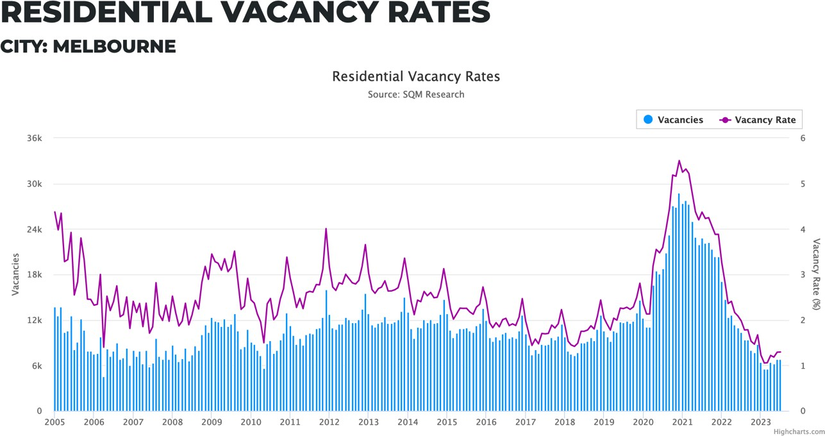
Figure 2: Residential Rental Rates 2005- 2023 Source: SQM Research 2023

The housing market in Australia, including Victoria is in crisis. Stakeholders continue to point towards factors that often suit their narrative. For example, tenant advocates claiming investors are being opportunistic in increasing rents, and in this, they are abrogating their social responsibilities. While investors argue they ought to attain commensurate yields for outlaid capital (somewhat overlooking the capital growth objectives), otherwise they see little benefit for investing in real estate. Residential investors in Australia typically invest in expectation of rental yields and capital growth, the latter often being the prime motivation. If this be the case, it is reasonable to expect investors to continue to invest in housing but probably on a more limited scale. Some are likely to be deterred by the increased stringency of regulation, taxes, and other investment risks. It is also likely to result in rented properties being more frequently sold as investors seek to take profit from capital growth. Natural market cycles affecting house price increase/decrease will also cause fluctuating levels of investment in housing, resulting in unstable rental stock levels. Without open recognition by all stakeholders that investors must be incentivised to invest to contribute to housing stock, the housing predicament is unlikely to be resolved any time soon.
This paper sought to review the current rental housing situation in Victoria with the aim of developing a research agenda to further examine the issues raised. There has been, and continues to be, significant quantities of research in this field but much of it tends to examine the renter’s perspective. However, as governments are unable or unwilling to position themselves as a major housing provider, serious consideration must be given to understand why investors invest or do not invest in housing. It is quite apparent to industry observers that current strategies are not achieving stated objectives. The authors argue this problem is the result of long-term neglect by successive governments and the solution requires a long-term approach.
As an initial step forward, the authors propose the following research themes ought to be considered:
- A deeper examination of investor attitudes towards residential investment acquisition and retention. Included in this topic should be an examination of attitudes to the issues raised in this paper, and any potential “breakpoints” where investors may choose to divest their residential asset.
- Development of a model to examine/predict the impact of regulation and taxes on housing supply.
- Develop a framework of policy recommendation that aims to address housing supply and barriers to supply faced by private smaller investors.
Numerous other topics would no doubt emerge as the research progresses and this paper only seeks to highlight the important issue of housing equity through providing a pragmatic perspective to forward a proposed research agenda. Housing inequality is one of the causal elements of crime rates and societal unrest (Sharghi et al 2022) and any steps towards a resolution will assist creating a healthier society.

References
ABS (2021a), Snapshot of Victoria, Australian Bureau of Statistics, accessed 25 June 2023. <https://www.abs.gov.au>
ABS (2021b), Census of Population and Housing: Snapshot of Australia data summary, 2021, accessed 14 August 2023, <https://www.abs.gov.au>
ATO (Australian Taxation Office) (2023), Taxation Statistics 2020-2021, accessed 14 August 2023, <https://www.ato.gov.au>
Consumer Affairs Victoria (2021), 2021 Victorian rental laws changes, Consumer Affairs Victoria, access 8 June 2023. https://www.consumer.vic.gov.au/housing/renting/2021-victorian-rental-laws-changes
Energy Victoria 2017, Bringing rental homes up to scratch”, accessed 27 June 2023, https://environmentvictoria.org.au/wp-content/uploads/2017/09/Bringing-rental-homes-up-to- scratch-Sept-2017-online.pdf
Forbes K (2023), How many Australians own investment property? Property Update website, accessed 14 Aug. 2023. <https://propertyupdate.com.au/how-many-australians-own-an-investment-property/>
Franke, M. and Nadler, C., 2019. Energy efficiency in the German residential housing market: Its influence on tenants and owners. Energy policy, 128, pp.879-890.
French N (2020) Property valuation in UK: climate change targets and the value of UK investment properties – a change in sea level, Journal of Property Investment & Finance, Vol. 38, No. 5, pp. 471-482
Haffner, M., Elsinga, M. and Hoekstra, J., 2008. Rent regulation: The balance between private landlords and tenants in six European countries. European Journal of Housing Policy, Vol. 8, No. 2, pp.217-233.
Heffernan, T.W., Heffernan, E.E., Reynolds, N., Lee, W.J. and Cooper, P., 2021. Towards an environmentally sustainable rental housing sector. Housing Studies, Vol. 36, No. 3, pp.397- 420.
Homes Victoria, (Department of Families, Fairness and Housing) 2022, Homes Victoria Rental Report, March 2022, accessed 14 August 2023, <https://www.dffh.vic.gov.au/publications>
Homes Victoria, (Department of Families, Fairness and Housing) 2023, Homes Victoria Rental Report, March 2022, accessed 14 August 2023, <https://www.dffh.vic.gov.au/publications>
Hughes, C., Sayce, S., Shepherd, E. and Wyatt, P., 2020. Implementing a land value tax: Considerations on moving from theory to practice. Land Use Policy, Vol. 94, p.104494.
Infrastructure Victoria (n.d.) Towards 2050: Gas infrastructure in a net-zero emissions economy, Infrastructure Victoria, accessed 8 June 2023. https://www.infrastructurevictoria.com.au/report/1-executive-summary/
Information on minimum energy efficiency standards for rental homes, accessed 27 June 2023. https://www.justice.act.gov.au/renting-and-occupancy-laws/energy-efficiency-standards-for- rental-homes
Jenkins, B. (2009) Rent Control: Do Economists Agree? Econ Journal Watch, Vol. 6, pp. 73– 112.
Kettunen, H. and Ruonavaara, H., 2021. Rent regulation in 21st century Europe. Comparative perspectives. Housing Studies, Vol. 36, No. 9, pp.1446-1468.
Law Library Victoria (2023), Residential Tenancies Victoria Research Guide, accessed 14 August 2023. <https://www.lawlibrary.vic.gov.au/residential-tenancies-victoria-research-guide>
Lang, M., Lane, R., Zhao, K. and Raven, R., 2022. Energy efficiency in the private rental sector in Victoria, Australia: When and why do small-scale private landlords retrofit? Energy Research & Social Science, Vol. 88, p.102533.
Villca-Pozo, M. and Gonzales-Bustos, J.P., 2019. Tax incentives to modernize the energy efficiency of the housing in Spain. Energy Policy, Vol. 128, pp.530-538.
Jalil, N.I.A. and Maidin, A.J., 2021. Developing Sustainable Residential Tenancies Scheme for Malaysia. Journal of Asian and African Social Science and Humanities, Vol. 7, No. 2, pp.1-12.
Mortgage house (2022), What is the average age to pay off a mortgage in Australia?, Mortgage House website, accessed 15 July 2023. https://www.mortgagehouse.com.au/news-resources/what-is-the-average-age-to-pay-off-a- mortgage-in-australia/
Sayce S and Hossain S (2020), “The Initial Impacts of Minimum Energy Efficiency Standards (MEES) in England.” Journal of property investment & finance Vol. 38, No. 5, pp. 435–447.
Schmid, C.U. and Dinse, J.R., 2013. European dimensions of residential tenancy law. European Review of Contract Law, Vol. 9, No. 3, pp.201-220.
Sharghi, A., Nourtaghani, A., Ramzanpour, M. and Gorji, R.B., 2022. Low-income housing location based on affordable criteria Using AHP Model and GIS Technique (Case Study: Babolsar City). Environment, Development and Sustainability, pp.1-41.
SQM Research, Weekly Rent, City Melbourne, SQM Research, accessed 25 June 2023. https://sqmresearch.com.au/weekly-rents.php?region=vic-Melbourne&type=c&t=1
SQM Research, Residential Vacancy Rates, City: Melbourne, accessed 13 August 2023. https://sqmresearch.com.au/graph_vacancy.php?region=vic-Melbourne&type=c&t=1
Smith, Adam. The Wealth of Nations: An Inquiry into the Nature and Causes of the Wealth of Nations. 1776.
Statista 2022, Distribution of property investors in Australia in 2022, by age group https://www.statista.com/statistics/1347272/australia-distribution-of-property-investors-by- age-group/
Van Gent, W. and Hochstenbach, C., 2020. The neo-liberal politics and socio-spatial implications of Dutch post-crisis social housing policies. International Journal of Housing Policy, Vol. 20, No. 1, pp.156-172.
Whitehead, C., Monk, S., Scanlon, K., Markkanen, S. and Tang, C., 2012. The private rented sector in the new century: a comparative approach. Copenhagen: Boligokonimisk Videncenter.

