Harnessing utilization data to revisit space needs in Activity-Based Workplaces: A case study
Samin Marzbanª, Ozgur Gocer^{b}, Behnaz Avazpour^{c}, Iva Durakovic^{d} and Christhina Candido^{c}
ª University of Wollongong
^{b} University of Sydney
^{c} University of Melbourne
^{d} University of New South Wales

ABSTRACT
The pandemic fast tracked organizations' re-evaluation of Corporate Real Estate footprints and costs, with many debating the need for space altogether. Harnessing utilization data and identifying differences between intended and actual use of various work zones is critical for tenants to reduce office footprint by designing workplace environments that achieve optimized fit between office infrastructure and post-pandemic ways of working. This paper reports on findings from a case study of a floor in an Activity-Based Workplace environment. 12 months of utilization data is analyzed to identify work zones more/less frequently used by workers and their respective physical attributes. Findings show workers prioritize work zones with visual access to daylight and nature, as well as assigned zones for individual work. Breakout spaces were the second most utilized, with open collaborative zones predominantly used by groups of four, while formal meeting rooms were underutilized. Internal, noise-prone zones close to lockers, entry points, or under air-conditioning outlets were least utilized. This case study demonstrates the value of a multi-dimensional analysis of workplace utilization patterns, environmental conditions and behaviour patterns in informing effective future real estate and design decisions.
Keywords: utilization ratio, Activity-Based Working, open-plan office, space planning, space utilization

INTRODUCTION
The 2020 pandemic and its consequent global financial downturn have no doubt accelerated discussions about real estate costs and the need to better understand how much space organizations need and if any space is needed at all (Boland et al., 2020; Naor et al., 2022). With so many offices sitting empty, space and the associated operational costs are under much scrutiny and it is likely that organizations will move faster to track utilization down. Indeed, considering that providing each worker with workspace has costs for organizations (Alker et al., 2015) reducing real estate makes for a compelling financial argument. While the drive to optimize space usage is not new and is well-accepted as strategic and timely, organizations often overestimate their space needs.
However logical and financially attractive it may be, quantifying the mismatch between planned and actual usage is still in many ways considered the holy grail of real estate management (Boland et al., 2020; Pajević, 2021). One of the main benefits of properly tracking space utilization is to be able to quantify how much and for how long space is not being used. It is not surprising then that over the years, the way workplace capacity is measured has evolved from space metrics (m2) to include the duration of time (m2 hours) it is available to people (CABE, 2005; Höjer & Mjörnell, 2018). In practical terms, it comes with the realization that zones within an office may be used only for a much smaller percentage of time they were designed to – it has been estimated that desks are not occupied the whole time in any typical working day (BCO, 2013; Kim et al., 2016).
This evidence-based approach, for example, can prompt changes in the way spaces are used by people to harness the power of organic learning and collaborative work ecosystems that may flourish from incidental meetings and social interactions. Research has found that workers who bond with each other and frequently spend time working together in teams tend to be more productive (Fayard et al., 2021; Whillans et al., 2021). Organizations have used knowledge of space utilization to simulate this effect, encouraging workers to take breaks in groups at the same location instead of individually, resulting in an estimated productivity increase (Candido et al., 2019; Waizenegger et al., 2020). Another study has found that the size of cafeteria’s lunch tables can also affect productivity – workers who sat at the 12-person table were more productive than their peers who sat at 4-seaters (Spence, 2015). These results further strengthen the case for the significant financial benefits of aligning usage with needs, while also highlighting the hidden benefits that are not always obvious. Knowing who uses the space, when and with whom can significantly boost productivity and the bottom line (Candido et al., 2020).

New Ways of Working and space utilization: harnessing the value of pervasive monitoring
The mismatch between planned and actual usage can be estimated by conducting space utilization studies (Gocer et al., 2022; Zhou et al., 2022). Traditionally, workplace utilization studies have been conducted by placing observer(s) in situ over a period of two or more weeks to record real and “in use” occupation at various times throughout the day (Zhou et al., 2022). These studies can reveal the percentage of space used, times and levels of use, and number of people using space. All of this information can be broken down per desk, team, floor, day and time, etc. This also highlights the importance of conducting a proper space appraisal before deciding to expand workplace’s footprint can benefit organizations financially.
New ways of working implementation has the potential to address some of the inefficiencies in the use of spaces by removing desk ownership thereby making the whole office available to mobile workers when they need based on the task they have at hand. Within the context of non-assigned seating offices designed to support Activity-Based Working (ABW), space utilization data helps reveal overall patterns of use, showing when and how long people spend their time while at the office, indicating spaces that are given preference by people (Candido et al., 2019; Gocer et al., 2022; Kim et al., 2016). Workplace utilization studies are integral to the process of implementing ABW by quantifying the square meters needed by organizations and cost-saving options coming from optimization. They provide much needed information to support the decision-making process which involves changes in space, technology and behaviour (Marzban et al., 2023; Nanayakkara et al., 2021).
One of the challenges when implementing ABW is to provide the right balance between zones that can be used on-demand, some requiring formal booking, and others not. Further, close monitoring of workers movement and utilization patterns can be used to remediate issues related to behaviour (Foley et al., 2016; Olsen et al., 2018), territoriality (Rolfö et al., 2018) and wayfinding (Mustafa & Azeez, 2022). While the snapshots in use provided by workplace utilization studies are valuable, they are limited to the time observers are in situ taking recordings. This point-in-time recording can be problematic in ABW-supportive environments as this approach is unlikely to fully capture fluctuations in space usage patterns of a mobile workforce.
With the pervasiveness of sensing technology within workplaces, spot observations can be replaced by analysis of longitudinal datasets of utilization. Passive systems are particularly accurate as they capture data without relying on workers engagement with the technology itself. Internet protocol detection is a good example of a passive system – computer logs provide information about where and when workers are using a device within the office (Brambilla et al., 2021). When combined with basic demographics, this type of dataset can provide much needed insight into where, when and with whom workers spend time during their workday which can unlock ways to reduce real estate overhead, maximize space utilization and enhance employee productivity (Candido et al., 2019). Despite its obvious potential, analysis of longitudinal utilization datasets in combination with occupant demographics and interior design attributes is not yet mainstream. This paper taps into this potential by presenting results of analysis of utilization patterns measured passively in an ABW-supportive office to identify differences between intended and actual use of spaces.

METHODOLOGY
One floor of a premium-graded commercial building was used as a case study for this paper. The landscaped office fit-out was designed to support ABW presenting workers with purposively assigned zones dedicated to different workstyles and equipped with synchronous and asynchronous collaborative tools to support agile ways of working. Floor plan analysis and site visits showed that the office fit-out offers workers five main types of work zones: enclosed meeting rooms; enclosed individual work rooms; shared open work areas (in perimeter and central zones); shared open concentration/focused areas; and shared open collaborative work areas.
The enclosed meeting rooms are situated within the interior zone of the building and serve as spaces for meetings in large or small groups. Enclosed individual work rooms are small rooms between central and perimeter zones. These rooms require booking to be used for a specific time usage. Shared open work areas are located in the south and north of the building, benefitting from natural light and external views. The desks within these areas are available for use without requiring prior booking. Shared concentration/focused areas are four open spaces intended for individual tasks that require focus with no distraction. These areas are situated at the four corners of the building with access to natural light and external views. Desks in these areas do not require booking. Two of these spaces are close to collaborative work areas (which may be used for members of the same team in close collaborative spaces) and two are at a distance from these areas. Shared collaborative work area consists of three open spaces along the perimeter of the building. These areas are at a distance from the focused areas and do not require booking. These rooms are used for teamwork, facilitating communication amongst team members working on the same task or project.
The one-year-long, longitudinal, presence-based dataset was analyzed, providing nearly 1000 records of the location and duration of their stay within the office. Geographical information system (GIS) has been used in mapping utilization patterns. A linear regression analysis was conducted to verify the relationship between the frequency of use in different zones of interest.

RESULTS

1. Overall appropriation of work zones by individuals
The data presented in Figure 1 (top) shows the percentage of active usage of work zones for the entire year. Enclosed individual rooms were mostly used by occupants (82.8%), followed by shared open areas including collaborative work areas (31.4%), work areas (28.9%), and focused areas (26.3%). The meeting rooms were only occupied 8.1% of the time throughout a year. A similar pattern was seen for all the two-hour time periods during business hours, with individual work rooms having the highest utilization percentage, followed by shared open collaborative work areas, while meeting rooms had the lowest utilization (Figure 1 bottom).
Areas designed to support collaborative work presented a very high active usage rate during peak hours (11 a.m.-1 p.m.). This work area is close to a variety of other spaces including individual rooms, meeting rooms and shared open work areas. Further, many of these collaborative work zones were occupied by the same employees for the majority of the time showing that people were choosing to work together, thereby organically creating a neighborhood. This will discussed further later in this paper.
Regarding the shared open work areas, there is higher utilization close to the northern façade compared to the southern façade. For the northern façade, the work areas in close proximity to both lockers and meeting rooms had a higher rate of active use. Proximity to windows and views also played an important role in attracting people to the perimeter zones, however, it was not the sole reason. In the southern façade, two clusters of shared work areas close to the central axis show higher rates of active use during peak hours. Employees tend to avoid spaces close to corridors and circulation areas, while they also prefer working near the windows and lockers. Interestingly, these work areas with higher active use are consistently occupied by the same workers.

Figure 1. Annual active use of zones (%) for: (top) average of the whole year, and (bottom) average for 2-hour time slots for studied zones.

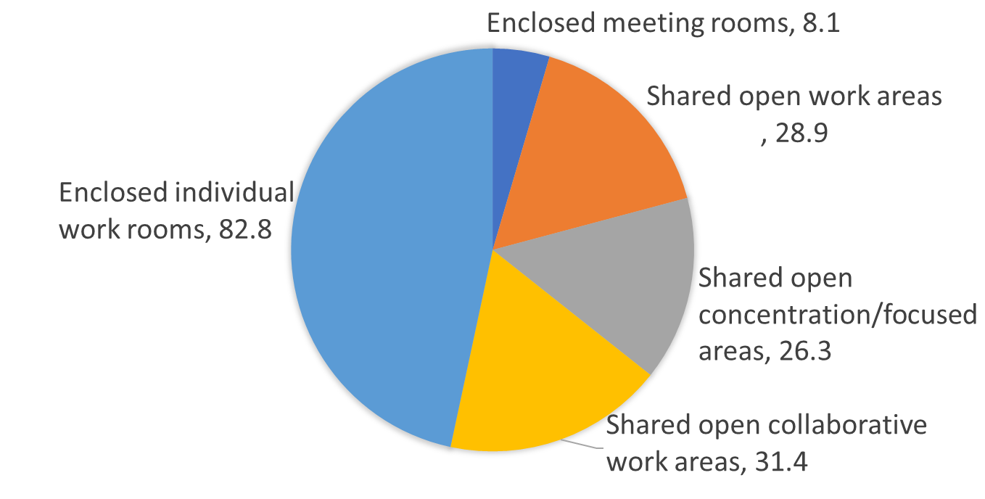
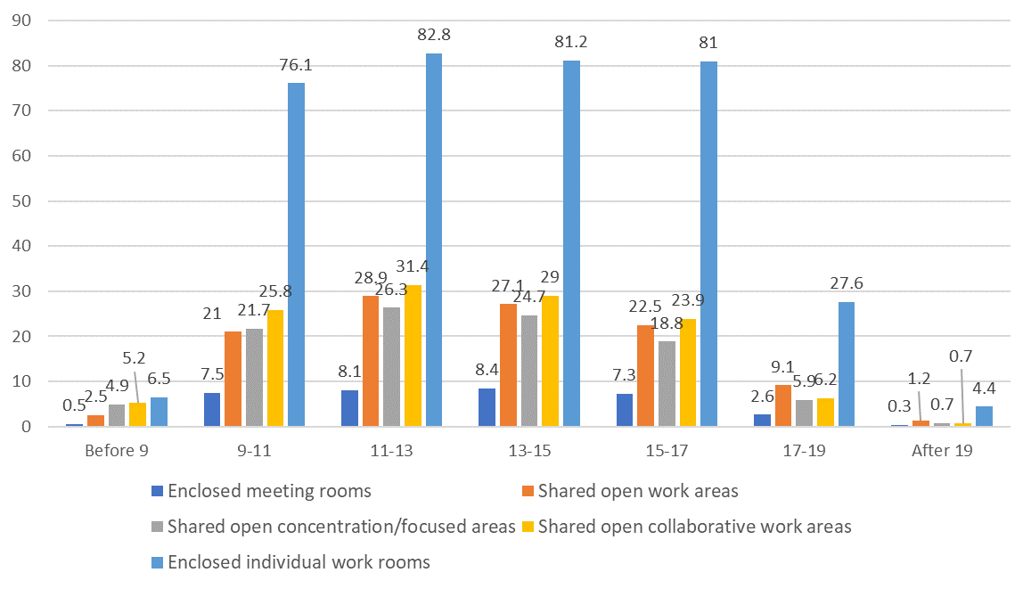
The focused workspaces are distributed in 4 main areas: northeast, west, southwest and east. The northeast corner is the least popular focused work area, possibly due to its proximity to the noisy collaborative work area. South-east, west and east-focused work areas have slightly higher active use levels compared to the north-east corner. Although the focused work area in the western façade was also in proximity of a collaborative workspace, the workers had the option to stay away from it by selecting to work further away from the possible noise generated in the collaborative work. Moving away from noise does not appear to be an option for the workers in the north-east focused zone, which is why this space has lower active use. When examining the annual active use of meeting rooms, and individual rooms, distinct utilization patterns emerge. Individual rooms are frequently used for short periods of time (25-87% of the time per day) considering the need to book them, but meeting rooms were only occupied for a maximum of 14% of the time.
In summary, the most frequently utilized space in the building is the enclosed individual work area, likely chosen for its privacy and opportunity to concentrate. Collaborative work areas are the second preferred spaces in this office that are close to the open work area. In addition to the importance of the location of these areas in the space configuration , which was also highlighted by Mustafa and Azeez (2022), the frequent utilization of these areas could also be attributed to factors such as access to natural light, external views, greenery, and natural textures within the space. These findings align with research by Browning and Ryan (2020), Gray and Birrell (2014), and Sanchez et al. (2018). Open work areas also share similar features in terms of access to natural light, greenery and textures positioning them as the third most frequently used spaces in the building. Within these open work areas, the spots that are closer to amenities such as lockers and meeting rooms are utilized more frequently. On the other hand, while the four focused areas benefit from natural light and external views, two spots are less utilized due to their proximity to the collaborative areas which could potentially distract workers.

2. Overall appropriation of work zones by groups of people
As the concept of neighbourhood defines as “a dedicated area for a team, project or department” (Young, 2020, p.1), was not implemented as a workplace strategy in the studied organization, an investigation on active use of the workstations by the same workers was conducted. To understand the relationship between the usage frequency of the workstation by the same group of occupants and the active use of that workstation during a year, linear regression analyses were conducted. Annual average active use was considered as a dependent variable and the frequency of the use of the same workstation by a group of people was an independent variable. The R2 and standardized regression coefficients (β) of the linear regression model were reported as 0.526 and 0.72, respectively. It has also been statistically significant (p<0.001) meaning that the same group of people used the same workstation.
The workstations that had been used by the same workers for more than 65% of the time are the spaces in the perimeter close to the windows. The majority of the work areas were occupied by the same worker at least 30% of the time, confirming that many workers return to the same workstations repeatedly and shape neighbourhood with some of their colleagues. These workers tend not to switch their workstations over the one-year period that the data was collected.
According to the analysis, a positive relation can be seen between the average active use of each workstation and the active use of the same workstation. The results indicated that the percentage of active use of a workstation was higher as the same workers tended to return to the same workstation repeatedly. This finding again confirms the idea of creating organic clustering by the workers when the neighbourhood concept is not introduced in a workplace.

DISCUSSION
The utilization patterns have been mapped in the ABW supportive office to identify differences between the intended and actual use of spaces by workers. Enclosed individual rooms were the most popular zones, followed by shared open collaborative, focused and work areas. Collaborative work areas in the proximity of a variety of areas including individual rooms, focused work, meeting rooms and shared work areas had a higher active use in peak hours throughout the year. Regarding the shared work areas, the popular spots are in proximity of lockers, meeting rooms, windows and views. Occupants working in focused work areas tried to avoid the noise from collaborative work areas. The workers’ preferences seemed to vary vastly in this case study, and this finding is aligned with findings from a study by Babapour et al. (2020). They reported that the same workstation might be a favorite location for some employees while others avoided it. Babapour (2019) also indicated the workers’ preference was due to functional, social, emotional and symbolic aspects of the workspaces as well as their physical structure and stimuli.
The majority of the work areas were occupied by the same worker at least 30% of the time, confirming that many workers return to the same workstations repeatedly and shape neighbourhoods with some of their colleagues. These workers tend not to switch their workstations over the one-year period that the data was collected. Whether these neighbourhoods were formed because the workers were working in a similar team or department, or whether the neighbourhoods were shaped due to personal interactions and friendships or a very specific design feature in the physical configuration of the space was not clear from the data.
These findings are aligned with several studies (Babapour, 2019; Babapour et al., 2018; Gocer et al., 2018) which presented evidence that some workers in open-plan offices designed to support ABW do not switch frequently enough between the workstations. Babapour et al. (2018) highlighted that the underlying reasons behind the non-appropriation of the desk-sharing policy and space usage were: (1) a misfit with the work needs (i.e., misfits with the participants’ concentrative needs) along with the increased time and effort to switch between work areas, (2) incompatibility with previous ways of working or with individuals’ artefacts such as laptops, (3) increased complexity and imposed limitation such as the use of paper documents, (4) unclear benefits, (5) complications in setup. Three studies by Gocer et al. (2018) and Haapakangas et al. (2018) showed a higher level of satisfaction among mobile workers (workers who switch more frequently among different workstations and zones). Whether returning to the same workstation and not switching in an ABW environment affected occupants’ satisfaction was not clear from our data.

DESIGN IMPLICATIONS
COVID has brought about significant changes in working arrangements. According to studies by Marzban et al. (2021) and Durakovic et al. (2022), although face-to-face interaction and business development were key priorities for returning to the office, workers are still unwilling to revert to pre-pandemic ways of working. On the other hand, organizations are trying to motivate workers to return to headquarters while also trying to manage the cost of their offices and/or reduce their office footprints by revising their workplace design. Looking ahead, the findings of this study highlight the importance of providing a supportive and adaptable working environment for workers to return to. According to this study, considering spaces to cater different types of activities including focused and collaborative tasks, integrating natural materials, natural light and external views, and equipping each workspace with appropriate amenities are critical factors that could enhance the use of workplaces and consequently the productivity of workers as also mentioned by Candido et al. (2019) and Sanchez et al. (2018).
It is clear from our data that individual and focused rooms had a very high active use regardless of their proximity. This could be because these spaces had a more enclosed design with less potential for distraction. The popular shared open work areas are in proximity of lockers, meeting rooms, windows and views and away from the collaborative work zones. This could be due to the noise generated by the collaborative work areas. These findings can inform modifications to the layout design to create more individual-focused spaces.

CONCLUSIONS
Office buildings have increasingly become alive organisms pulsating with data as a result of emerging technology such as smart sensors and devices. Having an accurate picture of how employees are using rooms, resources and space gives companies a chance to find ways to reduce their real estate overheads, maximize space utilization and enhance employee productivity—all while saving money. For years, actual usage has been the missing link in effective real estate management. Companies now have the opportunity to gain insight into the many ways they can improve their organization’s bottom line through effective management of real estate and resources. Investigating the mismatch between planned and actual utilization patterns can help improve underutilized workstations and work zones, replacing them with more desirable alternatives. The findings can provide invaluable insight into modifying the workplace based on the occupants’ post-relocation needs.

ACKNOWLEDGEMENTS
This research was funded by the Australian Government through the Australian Research Council’s Discovery Projects funding scheme (project DP190100705). The authors express their gratitude to AETMOS for their support to this research.

REFERENCES
Alker, J., M. Malanca, C. Pottage, R. O’Brien, D. Akhras, B. Ambrose, & J. Wong. (2015). ‘Health, Wellbeing and Productivity in Offices’ World Green Building Council. Available at: http://www.worldgbc.org/activities/health-wellbeing-productivity-offices/research.
Babapour Chafi M., Harder M., Bodin Danielsson C. (2020). ‘Workspace preferences and non-preferences in Activity-based Flexible Offices: Two case studies’, Applied Ergonomics, 8.
Babapour M., Karlsson M.A., Osvalder A.-L. (2018). ‘Appropriation of an activity-based flexible office in daily work’, Nordic Journal of Working Life Studies, 8.
Babapour M. (2019). From fading novelty effects to emergent appreciation of Activity-based Flexible Offices: Comparing the individual, organizational and spatial adaptations in two case organizations. Appl Ergon.
BCO. (2013). Occupier Density Study 2013.
Boland, B., De Smet, A., Palter, R., & Sanghvi, A. (2020). ‘Reimagining the office and work life after COVID-19’, McKinsey & Company.
Brambilla, A., Candido, C., Hettiarachchi, I., Thomas, L., Gocer, O., Gocer, K., Mackey, M., Biloria, N., Alizadeh, T. & Sarkar, S. (2021). ‘The potential of harnessing real-time utilization data for improving energy performance of activity-based workplaces’, Energies, 15(1), 230.
Browning, W. D., & Ryan, C. O. (2020). Nature inside: a biophilic design guide. Routledge.
CABE, D. C. (2005). The impact of office design on business performance.
Candido, C., Thomas, L., Haddad, S., Zhang, F., Mackey, M., & Ye, W. (2019). ‘Designing activity-based workspaces: satisfaction, productivity and physical activity’, Building Research & Information, 47(3), 275-289.
Candido, C., Marzban, S., Haddad, S., Mackey, M., & Loder, A. (2020). ‘Designing healthy workspaces: results from Australian certified open-plan offices’, Facilities, 39(5/6), 411-433.
Durakovic, I., Aznavoorian, L., & Candido, C. (2022). ‘Togetherness and (work) Place: Insights from Workers and Managers during Australian COVID-Induced Lockdowns’, Sustainability, 15(1), 94.
Fayard, A. L., Weeks, J., & Khan, M. (2021). Designing the hybrid office. Harvard Business Review, 99(2), 114-123.
Foley, B., Engelen, L., Gale, J., Bauman, A., & Mackey, M. (2016). ‘Sedentary behavior and musculoskeletal discomfort are reduced when office workers trial an activity-based work environment’, Journal of Occupational and Environmental Medicine, 58(9), 924-931.
Gocer, O., Goçer, K., Ergoz Karahan, E., İlhan Oygür, I. (2018). ‘Exploring mobility & workplace choice in a flexible office through post-utilization evaluation’, Ergonomics, 61(2), pp. 226-242.
Gocer, O., Candido, C., Gocer, K., Brambilla, A., Thomas, L., Billoria, N., Mackey, M., Alizadeh, T. & Sarkar, S. (2022). ‘Overlaps in space utilisation patterns and IEQ conditions observed in Activity-Based Working supportive office’, Building and Environment, 220, 109273.
Gray, T., & Birrell, C. (2014). ‘Are biophilic-designed site office buildings linked to health benefits and high performing occupants?’, International journal of environmental research and public health, 11(12), 12204-12222.
Haapakangas, A., Hallman, D.M., Mathiassen S.E., Jahncke H. (2018). ‘Self-rated productivity and employee well-being in activity-based offices: The role of environmental perceptions and workspace use’, Building and Environment, 145, pp. 115-124.
Höjer, M., & Mjörnell, K. (2018). ‘Measures and steps for more efficient use of buildings’, Sustainability, 10(6), 1949.
Kim, J., Candido, C., Thomas, l., de Dear. R. (2016). ‘Desk ownership in the workplace: The effect of non-territorial working on employee workplace satisfaction, perceived productivity and health’, Building and Environment, 103 (2016), pp. 203-214,
Marzban, S., Candido, C., Mackey, M., Engelen, L., Zhang, F., & Tjondronegoro, D. (2023). ‘A review of research in activity-based working over the last ten years: Lessons for the post-COVID workplace’, Journal of facilities management, 21(3), 313-333.
Mustafa, F. A., & Azeez, S. A. (2022). ‘Role of office layout typology in saving time and distance spent by users: Case of office buildings in Erbil city’, Ain Shams Engineering Journal, 13(5), 101742.
Nanayakkara, K., Wilkinson, S., & Halvitigala, D. (2021). ‘Influence of dynamic changes of workplace on organizational culture’, Journal of Management & Organization, 27(6), 1003-1020.
Naor, M., Pinto, G. D., Hakakian, A. I., & Jacobs, A. (2022). ‘The impact of COVID-19 on office space utilization and real-estate: a case study about teleworking in Israel as new normal’, Journal of Facilities Management, 20(1), 32-58.
Olsen, H. M., Brown, W. J., Kolbe‐Alexander, T., & Burton, N. W. (2018). ‘Physical activity and sedentary behaviour in a flexible office‐based workplace: Employee perceptions and priorities for change’, Health Promotion Journal of Australia, 29(3), 344-352.
Pajević, F. (2021). ‘The Tetris office: Flexwork, real estate and city planning in Silicon Valley North, Canada’, Cities, 110, 103060.
Rolfö, L., Eklund, J., & Jahncke, H. (2018). ‘Perceptions of performance and satisfaction after relocation to an activity-based office’, Ergonomics, 61(5), 644-657.
Sanchez, J. A., Ikaga, T., & Sanchez, S. V. (2018). ‘Quantitative improvement in workplace performance through biophilic design: A pilot experiment case study’, Energy and Buildings, 177, 316-328.
Spence, D., (2015). ‘3 Things to Know About Space Utilization Technology’. Available at: https://www.officespacesoftware.com/blog/3-things-to-know-about-space-utilization-technology/ (accessed 2 February 2021)
Waizenegger, L., McKenna, B., Cai, W., & Bendz, T. (2020). An affordance perspective of team collaboration and enforced working from home during COVID-19. European Journal of Information Systems, 29(4), 429-442.
Whillans, A., Perlow, L., & Turek, A. (2021). ‘Experimenting during the shift to virtual team work: Learnings from how teams adapted their activities during the COVID-19 pandemic’, Information and Organization, 31(1), 100343.
Wohlers, C. & Hertel, G. (2018). ‘Longitudinal effects of activity-based flexible office design on teamwork’, Frontiers in Psychology, 9(2016).
Young, J. (2020). ‘Office Neighborhoods: benefits, definitions and implementation tips’, Smartway. Available at: https://smartway2.com/office-neighborhoods/#:~:text=Activity%20Based%20Working%20(ABW)%20is,sub%2Dset%20of%20agile%20working.&text=Rather%20than%20having%20your%20own,for%20socialising%20and%20so%20on. (accessed 13 April 2021).
Zhou, Y., Hua, Y., & Liu, J. (2022). ‘Study workplace space utilization: A review of measures and technologies’, Journal of Facilities Management, 20(3), 350-368.

