NEW WORKING PRACTICES POST COVID AND THEIR IMPACT ON ORGANISATIONAL CULTURE

Kusal Nanayakkara¹, Sara Wilkinson² and Dulani Halvitigala³

^{1& 3} RMIT University, Melbourne
2 University of Technology Sydney

ABSTRACT
COVID disrupted the global labour markets, causing sudden, severe changes to the physical use of office spaces. Australia’s $40 billion office market had not been immune to the impact of the pandemic, with the sector’s revenue falling significantly in 2020-21 due to subdued demand and work-from-home directives. As part of a wider project that examines how the organisational culture of large organisations may have changed with the introduction of hybrid and more flexible work practices since COVID, this paper aims to present the preliminary findings by analysing the existing literature on the research topic.
A document analysis of industry and market reports was conducted to identify the changes in office space demands which may have impacted organisations’ corporate culture. The findings identify that disruptions prompted many corporates to rethink their workplace requirements, and more landlords are looking to better integrate flexible spaces into their portfolio strategies. The ‘core plus flex’ model has become a popular emerging strategy that offers organisations the ability to integrate traditional leased space and flexible office arrangements. Many aspects of corporate culture and the feeling of belonging have changed significantly in the digital environment since COVID, and these require examination.
Keywords: Office buildings, Flexible office layouts, Organisational culture, Occupier satisfaction

Introduction

The COVID-19 pandemic had a significant impact on global labour markets, causing sudden changes in how office spaces are used. Even Australia's $40 billion office market was not spared, experiencing a significant drop in revenue due to reduced demand and work-from-home directives in 2020-21. Although the pandemic's health concerns have significantly reduced, many employees have been hesitant to return to the office (Property Council of Australia, 2022). During the pandemic, some employees experienced an improvement in their work- life balance due to not having to commute to the office (Baert et al., 2020). This has raised concerns regarding whether the traditional Monday-to-Friday, nine-to-five model will resume, or if people are comfortable working in shared offices. By early 2022, research found that only 40% of all global office workers had returned to the office, but it was expected to increase to approximately 60% by early 2023 (CBRE, 2021).
Many organisations are increasingly adopting hybrid work approaches, but a potential downside for employees is the lack of energy in the office. When a large number of people work away from the workplace, the deserted workstations and empty work café can leave those in the office feeling like they are at the wrong party. Research shows that when people experience stimulating or inspiring spaces, they feel a greater sense of community and belonging, which leads to higher engagement, productivity, innovation, and retention (Harris, 2021). If employees were not enamoured with their offices before COVID-19, they might be even less excited about them now as expectations for a great work experience have risen. In the future, if more work is hybrid and people work from home more often, they may struggle to connect with colleagues, the organisation, and its culture on a regular basis.
It is crucial for landlords to have office workers return to the workplace to maintain their return on investment, income growth, capital returns, and the assets’ physical, operational, and functional standards. The physical office is more effective in supporting employee engagement, collaboration, productivity, creativity, innovation, and the culture of the organisation, compared to remote working (Cushman and Wakefield, 2020). Research shows that there was a clear decrease in office worker productivity during the pandemic, as reported by Investa (2020). Additionally, remote working for extended periods can negatively impact employees’ physical and mental health and increase isolation, particularly Generation Z staff (Microsoft, 2021).
Having a strategically relevant culture can enhance both the performance of an organisation and the well-being of its employees (Hofstede et al., 2010). Organisational culture, as defined by Schein (1992), is "a pattern of shared basic assumptions that a group learns as it solves its problems of external adaptation and internal integration that has worked well enough to be considered valid and, therefore, to be taught to new members as the correct way to perceive, think, and feel in relation to those problems" (p. 12). By evaluating an organisation's mission statement, which answers the questions "who are we?", "what do we do?", and "where are we headed?", one can identify its culture, philosophy, ethical policy, pathway, and target destination (Hofstede et al., 2010). The layout and design of an office are also important in defining an organisation's culture, as they represent its corporate image (Tharp, 2009). In fact, an organisation's physical space is a silent communicator of its existing culture (Knight Frank, 2017). As perceptions of the office change, the modern workplace can be used as an instrument to drive the preferred culture and productivity of organisations, impacting their financial, cultural, and layout ethos. Therefore, it is crucial to gather systematic evidence on how organisational cultures have been affected, positively and negatively, by the COVID-19 pandemic.
This paper presents the current literature on how the culture in organisations may have changed with the COVID-19 pandemic and the shift to remote work and different office layouts. It is part of a wider research project that aims to examine how the culture in organisations may have changed with the changes in flexible work practices and physical office spaces since the pandemic and how this impacts future space needs and the nature of space offered in office buildings.

CHANGES IN WORK PRACTICES SINCE COVID-19
The COVID-19 pandemic, which began in late 2019 and continues to impact the world, has caused significant changes in society. One of the most notable changes has been in the world of work. As the pandemic unfolded, organisations and employees had to quickly adapt to new circumstances. This has led to changes in work practices that are likely to shape the future of work (Cushman and Wakefield, 2020). The most obvious change has been the increase in remote work. As lockdowns and social distancing measures were implemented worldwide, many organisations switched to remote working to ensure business continuity while minimising health risks (ARUP, 2020). Before the pandemic, remote work was often considered a privilege for selected employees. However, the pandemic has shown that remote work is feasible on a large scale. According to a study by Brynjolfsson et al. (2020), most non-essential service workers worked remotely fulltime compared to a small percentage before the pandemic. Remote work has emphasised the importance of flexible work arrangements that allow employees to balance work with personal responsibilities. This flexibility is expected to remain an essential aspect of the post-pandemic workplace. To support efficient remote working, organisations have accelerated their digital transformation efforts by investing in technologies that facilitate remote collaboration, communication, and productivity (Knight Frank, 2020).
Despite the widespread adoption of remote work during the pandemic, it became clear that certain tasks and positions were not conducive to being performed from home. As evidenced by Figure 1, white collar productivity in Australia experienced a significant decline throughout COVID-19, despite the fact that most office-based work was transitioned to home offices effectively (Investa, 2020).
Figure 1: Australian labour productivity
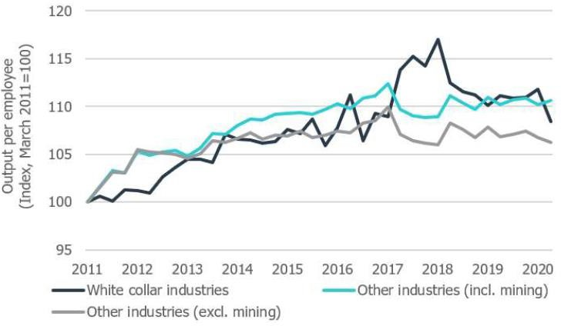
(Source: Investa, 2020)

Despite concerns about reduced productivity, many organisations are adopting hybrid work models that combine in-office and remote work, even after the pandemic's minimal impact. These models aim to provide employees with flexibility in choosing where and how they work based on the nature of their tasks and personal preferences. According to a Microsoft survey conducted in 2021, 73% of workers desire continued remote work flexibility, and 66% are considering changing jobs if their employer does not offer such flexibility. Most office markets worldwide report that office attendance has reached a steady state, and a return to pre-pandemic levels is unlikely, with less than 50% of space highly utilised in all markets observed (CBRE, 2023a) (See Figure 2). Consequently, organisations must find innovative ways to maintain a cohesive organisational culture when employees are physically dispersed. Managers must adapt their leadership styles to effectively lead remote and hybrid teams by emphasising results and outcomes over physical presence.

Figure 2: Average weekly office utilisation rates (headcount/desk count)
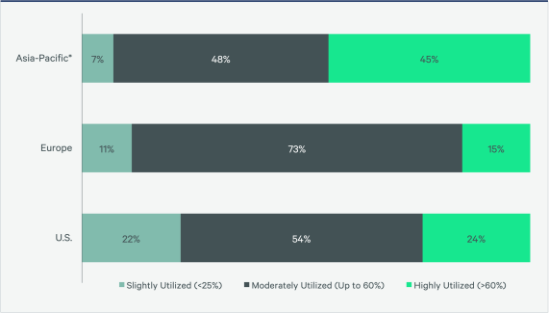
(Source: CBRE, 2023a).

CHANGES IN OFFICE SPACE DEMAND AND LEASING PRACTICES SINCE COVID-19
The pandemic has caused unprecedented disruptions in the global office space demand and leasing practices. Lockdowns, remote work mandates, and health concerns have led to significant changes in the office landscape. The most notable trend in leasing practices since COVID has been the decrease in office space demand (ARUP, 2020). With remote work becoming a necessity during lockdowns, many organisations have realised that a significant portion of their workforce can function effectively from home. As a result, there has been a reassessment of office space needs and a reduction in space requirements.
The acceptance of hybrid work arrangements has led many organisations to reconsider their office space requirements. This has resulted in a shift towards smaller office footprints and more adaptable work schedules, such as flexible work hours and staggered shifts. With not all employees needing to be present in the office simultaneously, downsizing office space has become an attractive option for organisations facing economic challenges. This can result in cost savings for rent, utilities, and maintenance expenses. Hybrid working has also been shown to reduce operating costs, with employers saving approximately $11,000 per year for every employee who works remotely half of the time (ARUP, 2020). Office space strategies vary by region, but the general trend is towards further rightsizing over the next three years (CBRE, 2023a). Many organisations plan to reduce their space by letting leases expire, subleasing excess space, and consolidating into fewer locations. Table 3 provides a detailed overview of organisations' office space strategies.

Figure 3: Organisations’ real estate strategies in the next 3 years
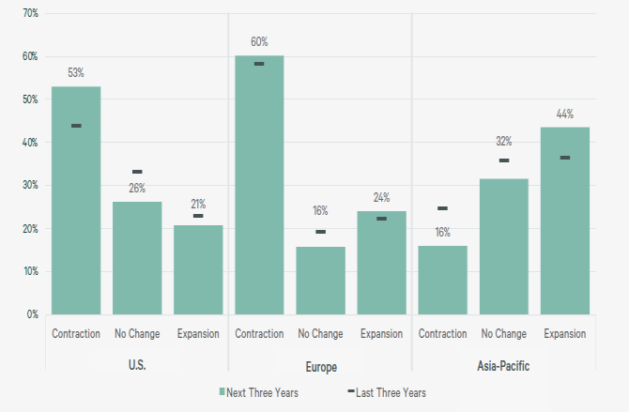
(Source: CBRE, 2023a).
Aligning with this global trend, in Australia, as shown in Figure 4, the net growth in total office leasing demand (net absorption) is still subdued with uncertainty and cautious business sector sentiment impacting office leasing decisions (Investa Research, 2023).

Figure 4: Australian leasing activity vs. net growth in leased stock
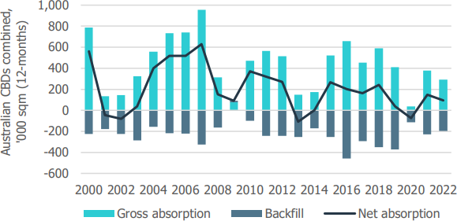
(Source: Property Council and Investa Research, 2023).

Post-pandemic, tenants in Australian office markets are also displaying a consistent inclination towards upgrading their office spaces, both across and within different office market grades. This trend is driven by their preference for prime quality spaces that offer a blend of high performance, improved experience and increased flexibility (Investa, 2023). As a result, secondary grade offices face significant challenges as the demand for such spaces are decreasing (See Figure 5).

Figure 5: Australian CBD leased office stock
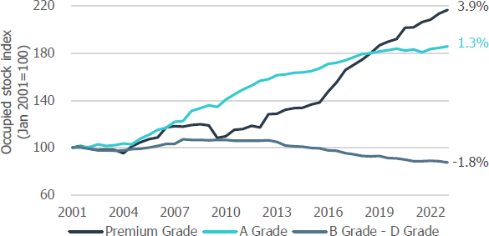
(Source: Property Council and Investa Research, 2023).

Amid the pandemic, many organisations have also reconfigured their office layouts in response to evolving health concerns. Open-plan offices, once popular for promoting collaboration, have come under scrutiny due to their potential for facilitating the spread of illnesses, at least in the short-term. This has led to reconfiguring space to ensure physical distancing while enabling the office to operate at optimal or reduced (30-50%) occupancy (CBRE, 2021). This is achieved by creating fewer desks, clear plastic screens between workstations, fewer seating options in communal areas and staggered seating in meeting rooms (CBRE, 2021). Prior to COVID, many organisations were transitioning to activity-based working environments, where employees have the flexibility to select the type of workspace that best suits their tasks, whether it is a quiet area for focused work or a collaborative space for team meetings. However, with the shift to remote work, this costly exercise now seems underused as approximately 40% of employees work from home (Veldhoen, 2020).
The shift to remote work has necessitated changes in communication and collaboration practices, and as a result, there has been a growing emphasis on providing amenities that enhance employee well-being. In reevaluating office spaces, there has been a focus on creating attractive environments that offer features such as wellness rooms, outdoor spaces, and high-quality air filtration systems (CBRE, 2020). These amenities are intended to make the office a more appealing destination for employees who may have grown accustomed to the comforts of working from home. By prioritising well-being, organisations hope to strike a balance between remote work and the in-office experience, creating spaces that employees genuinely enjoy.
Furthermore, the pandemic has had a significant impact on the location preferences for office spaces. Traditionally, central business districts (CBDs) were the most desirable locations due to their easy accessibility and proximity to amenities. However, in light of the rise of remote work, some organisations are now exploring alternative locations. Suburban and decentralised office spaces have become more attractive due to their potential to reduce commuting times and provide a more spacious, low-density environment (CBRE, 2020). This shift in location preference may have long-term implications for the dynamics of urban and suburban office property markets.
In response to the pandemic, organisations are also seeking greater lease flexibility to adapt to the uncertainties it has brought. This has led to a reconsideration of traditional long-term leases in favour of shorter lease terms or flexible leasing options that allow for agile responses to changing circumstances. According to CBRE (2023a), around 60% of companies in Europe expect some degree of portfolio contraction over the next three years, with 41% of companies favouring shorter lease terms (See Figure 6). There is a growing appetite for flex space, with some occupiers prepared to consider higher allocations of flex office space than in the past. As a result, the ‘core plus flex’ model has emerged as a popular strategy that offers organisations the ability to integrate traditional leased space and flexible office arrangements in their portfolios (CBRE, 2020). Landlords are also willing to negotiate lease terms and offer concessions to retain or attract tenants. These changes reflect a recognition of the need for flexibility in a rapidly evolving business landscape.

Figure 6: Focus areas for office space demand
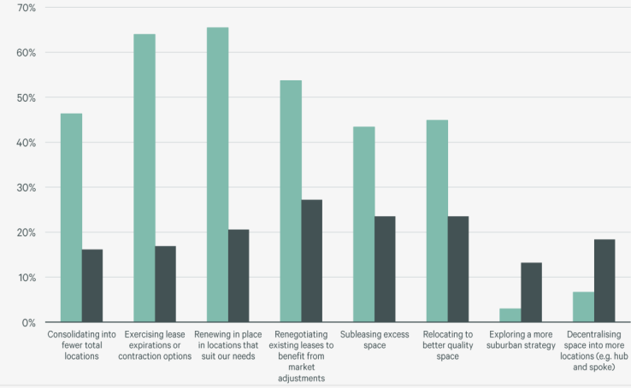
(Source: CBRE, 2023a)
In response to the heightened demand for flex spaces, landlords are now considering them a necessary addition to their portfolio, in order to meet tenants' increasing need for flexibility. A notable trend in the Australian flex market is the growing presence of larger landlords, including Dexus, Lendlease, and GPT, among others, who not only offer flexible space to tenants but are also expanding their offerings in response to the anticipated surge in demand over the next few years (CBRE, 2023b).

IMPLICATIONS OF SUCH CHANGES ON ORGANISATIONAL CULTURE
Changes to work practices and office layouts can impact leadership, the organisation's orientation, and its culture. Organisational culture refers to the values, beliefs, and behaviours that shape how an organisation operates and how its employees interact. The Competing Value Framework (Fairs, 2016) is a widely accepted framework used to distinguish the dimensions of organisational culture. Cameron and Quinn (2006) identified four cultural dimensions in this framework:
- Hierarchy culture
- Market culture
- Clan culture
- Adhocracy culture

- Hierarchy culture – It emphasises uniformity and strong control of the organisation with empowering coordination, evaluation, and internal efficiency (Cameron and Quinn, 2006). The main characteristics are hierarchy, rules, meritocracy, accountability, specialisation, separate ownership, and impersonality (Übius and Alas, 2009). Employees have a specific and formal place to work in order to achieve key values with fast, efficient and reliable production flows (Denison et al., 2004; Übius and Alas, 2009).
- Market culture – This culture emerged in the late 1960s since hierarchy culture could not provide flexibility for organisations when meeting strong market competition (Cameron and Quinn, 2006). It focuses on competing and reaching set goals with unsupportive external factors, such as public regulations (Übius and Alas, 2009). Open-plan offices were introduced into large corporates to facilitate this type of culture (Brunia et al., 2016).
- Clan culture – The main focus of this culture is maintaining better relationships and providing greater flexibility to employees to perform their jobs. Trust, involvement, teamwork, and corporate commitment to staff are the key characteristics (Übius and Alas, 2009). Flexible work practices and flexible office layouts appear to be the most suitable for this cultural dimension.
- Adhocracy culture – This culture emerged when the developed world moved to the information age from the industrial age (Cameron and Quinn, 2006). The focus is on creativity, innovation, and resource acquisition (Fairs, 2016). Since it is important to provide quiet working spaces with minimum disturbances for work that requires intense concentration, individual offices for employees with sufficient spaces for team collaboration are considered to be suitable for this type of culture (Fairs, 2016).
Organisational culture has traditionally been closely tied to physical office spaces, with various dimensions of this culture deeply ingrained in the workplace (Nanayakkara et al., 2023). However, the rise of new workingpractices has challenged and transformed these traditional norms. While remote work offers greater flexibility and the ability to work from any location, it has also disrupted existing organisational culture. Remote work has changed communication dynamics, reducing the frequency of informal office interactions. As a result, employees now rely on digital tools for communication, which has impacted the spontaneous and casual exchanges that once characterised office culture (Barrero et al., 2021). This might have negatively affected the presence of ‘clan culture’ dimension in organisations. However, research found that many organisations that had fostered a sense of belonging before COVID made significant efforts to bring people together in remote working. For example, in Australia, a survey of 800 office workers revealed that there was no difference in workplace trust and belonging between remote and office workers in 2020 (Davis, 2020).
With the onset of the COVID-19 pandemic, many organisations were compelled to emphasise certain cultural elements and downplay others (Brown et al., 2021). Specifically, organisations placed greater emphasis on five cultural elements: flexibility, transparency, supportiveness, decisiveness, and confronting conflict. Conversely, organisations deemphasised five cultural elements in response to the pandemic: customer orientation, individualism, detail orientation, results orientation, and collaboration. Overall, organisational cultures in the pandemic era have shifted away from a high performance orientation to one that prizes empathy, understanding, and mutual support (See Figure 7).

Figure 7: Cultural attributes that became more and less prominent during the COVID-19 pandemic
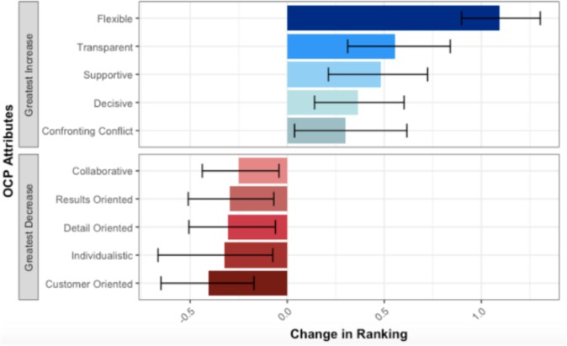
(Source: Brown et al., 2021)

The study conducted by Brown et al. (2021) found that remote working had a negative impact on employees' experiences of accessing resources and communication and collaboration practices. However, the only element of workplace culture that improved was regular leadership communication, as perceived by employees. While most organisations managed to transition to remote work without a significant decrease in productivity, the shift was challenging for many, potentially leading to detrimental consequences for the overall cultural vitality of the organisation. Additionally, the study found that different employee groups had significantly different experiences of these cultural changes. Non-white participants reported having a more negative experience of the pandemic and felt less optimistic about the future compared to white participants. This disparity could be attributed to non-white participants' perception of lower transparency in their organisational culture following the pandemic, relative to white participants. Evidence points to remote work preferences being highly gendered, with women more likely to value working from home than men, and men likely to prefer working in the office more days per week in emerging hybrid models (Dishman, 2021).
Due to organisations’ and employees’ willingness to continue with hybrid working, many organisations currently focus on outcomes and performance rather than measuring productivity based solely on time spent in the office (Forbes, 2020). A results-oriented culture promotes accountability and empowerment and fosters a culture of trust and autonomy (Forbes, 2020; Benton, 2020). This may have promoted more ‘market culture’ dimension among such organisations. The shift leads to a more efficient and effective work environment and a culture that values individual and collective achievement (Deloitte, 2019). New working practices emphasise flexible schedules, allowing employees to tailor their work hours to accommodate personal needs and preferences. This shift promotes a culture that values work-life balance, leading to higher job satisfaction and overall well-being (World Economic Forum, 2020).
New working practices which had to follow with COVID restrictions, prioritise ongoing skill development to remain productive and adaptable (Deloitte, 2019). Organisations that invest in training programs and resources empower employees to acquire new skills and stay relevant in their respective industries. A culture of continuous learning promotes innovation and adaptability, allowing organisations to navigate challenges and seize opportunities in a rapidly evolving landscape. By fostering this culture, organisations position themselves as learning-oriented and forward-thinking. Digital tools and platforms are leveraged to streamline processes, enhance communication, and facilitate remote collaboration. Cloud-based software, project management tools, and video conferencing platforms have become indispensable components of the modern workplace (Thomas, 2020; Brynjolfsson & McAfee, 2014). While technology integration offers numerous advantages, organisations must balance it with maintaining a human-centric work culture. It is crucial to ensure that employees do not feel overwhelmed or isolated by technology. Organisations can promote digital etiquette, provide training on technology usage, and encourage personal connections to maintain a collaborative and inclusive culture (Thomas, 2020).
During the pandemic, organisations have recognised the importance of prioritising the safety and well-being of their employees in their working practices. Where organisations have clear communication with their employees, wellbeing and productivity metrics are moving ahead very quickly, although where it is absent, employees are nearly three times more likely to report burnout (Alexander et al., 2021). This has resulted in initiatives such as mental health programs, wellness benefits, and promoting a healthy work-life balance becoming integral to organisational culture in some organisations (ARUP, 2020). By cultivating a culture of well-being, organisations demonstrate their commitment to their employees' holistic health, which in turn enhances the organisation's reputation and attracts top talent.
In addition, modern working practices emphasise the fundamental principles of diversity and inclusion. Organisations are actively working towards creating inclusive work environments that value and celebrate differences (Kulik, 2014). Such inclusive workplaces foster innovation, creativity, and a sense of belonging among employees. However, remote working has had a negative impact on this culture. Therefore, organisations must implement incentives to bring employees back to the office to reinforce this culture. Inclusive cultures are not only ethically sound but also contribute to enhanced organisational performance and reputation, which has been diluted since remote working began (Rockström et al., 2009).
While remote work offers flexibility, it can also lead to feelings of isolation, making it imperative for organisations to reassess their communication and collaboration strategies. The use of digital tools such as virtual meeting platforms and collaborative workspaces can promote an organisational culture of inclusivity and connectivity. However, the effectiveness of these tools depends on clear communication and leadership, and there is a risk of neglecting the organisational culture while prioritising effective digital communication (Barsade, 2020).
The COVID-19 pandemic has led organisations to reevaluate their office space needs and leasing trends, which could result in significant financial implications. Downsizing office spaces can lead to cost savings, freeing up resources for other strategic initiatives or employee-centric benefits. However, this approach must be handled transparently to avoid employee anxiety and maintain trust, which is a crucial aspect of organisational culture (CIPD, 2021). Organisations that prioritise employee well-being and collaboration in their office space reconfiguration are more likely to foster a culture that values comfort, safety, and innovation. The physical office becomes a symbol of an organisation's commitment to its employees' physical and emotional well-being. A welcoming and innovative office design can serve as a cultural hub, promoting interaction and creativity (Jones, 2021).
In a hybrid work environment, leadership styles should also be tailored to the type of organisational culture. Organisational cultures that foster adaptability and continuous learning among leaders are better equipped to facilitate a smooth transition to this new paradigm, ensuring that employees receive the necessary support and guidance (PwC, 2021). A robust organisational culture is now a competitive advantage in attracting and retaining top talent. Employees expect workplaces that align with their values, offer flexibility, and prioritise well-being. Those organisations that can successfully adapt their culture to accommodate these preferences will have an edge in the war for talent (Gallup, 2021). In addition, organisational culture influences innovation and adaptability. A culture that encourages experimentation, embraces change, and values diverse perspectives is better suited to thrive in dynamic and uncertain environments (Deloitte, 2020).
In summary, the organisational culture in a hybrid environment must prioritise inclusivity, adaptability, and leadership development. In this evolving landscape due to the continuous impact of COVID, organisational culture is not a static entity but a dynamic force that can shape an organisation's success. A culture that values trust, inclusivity, well-being, and adaptability can be a source of competitive advantage, attracting and retaining top talent while fostering innovation and resilience. Brwon et al. (2021) provide following recommendations for organisations to identify and maintain appropriate culture type for their organisations since the COVID-19 pandemic:

- Assess the operational effectiveness of the cultural modifications that have been implemented within the organisation in response to the pandemic, and identify those that can serve as a catalyst for future growth and innovation.
- Conduct a thorough analysis of the cultural components that have been repressed as a result of the pandemic and require reinforcement in order to maintain their competitive advantage.
- Organisations can maintain advanced cultural maps by employing surveys and analysing internal digital trace data. These maps can offer real-time insights into the evolving culture of the organisation and assessments of employees' perceptions about the culture.

CONCLUSIONS
The COVID-19 pandemic has triggered significant changes in work practices, leading to an increase in remote work and hybrid work models, a reconceptualisation of the purpose of physical offices, a focus on employee well-being and mental health, alterations in communication and collaboration practices, and an enhanced emphasis on upskilling and reskilling. These changes have far-reaching implications for the future of work, organisational culture, and the employee experience. As organisations navigate the challenges and opportunities presented by these transformative shifts, the post-pandemic workplace is expected to continue evolving, fundamentally transforming the way people work and interact in the years ahead.
As remote working becomes more prevalent, it is crucial for organisations to assess the impact it will have on their space requirements and corporate culture. Many companies use their values and practices, such as training, on-the-job learning, and mentoring, to attract employees, which are often more tangible in a formal office setting. Maintaining these practices will be paramount for organisations' corporate culture, particularly as employees spend more time away from the workplace. Organisations must ensure that their values are understood and put into practice in hybrid and flexible work arrangements with a more distributed workforce. Employers must have a thorough understanding of their staff's aspirations, help them grow, recognise leadership, and provide support in distributed work environments. Many aspects of corporate culture and the sense of belonging have undergone significant changes in the digital environment since the COVID-19 pandemic, necessitating examination.
Establishing a culture that aligns with the agile nature of a newly formed organisation is crucial in ensuring that employees continue to feel empowered to perform their duties while working remotely. As the organisation transitions to a network structure, managers and employees will experience varying degrees of change, with managers having less authority due to the easing of reporting lines and employees adapting to a more fluid environment with less structure and stability in their roles. To overcome these challenges, it is essential to be transparent and articulate the vision and values of the future organisation while providing transitional support to ease employees' concerns during this phase. This proposed research aims to empirically examine the impact of flexible work practices and changes in physical office layouts on the organisational culture since the pandemic from the perspectives of organisations and their employees.

REFERENCES
Alexander A., de Smet, A., Langstaff, M. and Ravid, D. (2021). What employees are saying about the future of remote work, McKinsey and Company, viewed 25/09/2023, https://www.mckinsey.com/business- functions/organization/our-insights/what-employees-are-sayingabout-the-future-of-remote-work
ARUP (2020). Future of offices in a post-pandemic world, viewed 25/09/2023, https://www.arup.com/perspectives/publications/research/section/future-of-offices-in-a-post-pandemic-world
Barrero, J, Bloom, N & Davis, S (2021). Why working from home will stick, Becker Friedman Institute: University of Chicago, viewed 25/09/2023, https://bfi.uchicago.edu/working-paper/why-working-from-home- will-stick/
Barsade, S. G. (2020). The Coronavirus Is Redefining How We Work. Harvard Business Review.
Baert, S., Lippens, L., Moens, E., Weytjens, J. and Sterkens, P. (2020). IZA DP No. 13229, ‘The COVID-19 crisis and telework: A research survey on experiences, expectations and hopes’, IZA Institute of Labor Economics, viewed 25/09/2023, https://www.iza.org/publications/dp/13229/ the-covid-19-crisis-and- telework-a-research-survey-on-experiences-expectations-and-hopes
Benton, A. (2020). Trust is the ultimate currency: Leading in the remote workplace. Forbes.
Brown, N.D., Chen, Y., Harrington, H., Vicinanza, P., Chatman, J.A., Goldberg, A. and Srivastava, S. (2021). How Have Organisational Cultures Shifted During the COVID-19 Pandemic, viewed 25/09/2023, https://cmr.berkeley.edu/2021/07/how-have-organisational-cultures-shifted/
Brunia, S., De Been, I. and van der Voordt, T.J.M. (2016). Accommodating new ways of working: lessons from best practices and worst cases, Journal of Corporate Real Estate, 18(1), 30 – 47
Brynjolfsson, E., Horton, J. J., Ozimek, A., Rock, D., Sharma, G., & TuYe, H. Y. (2020). COVID-19 and remote work: An early look at US data. NBER Working Paper No. 27344.
Brynjolfsson, E., & McAfee, A. (2014). The second machine age: Work, progress, and prosperity in a time of brilliant technologies. W. W. Norton & Company.
Cameron, K. S. and Quinn, R. E. (2006). Diagnosing and changing organisational culture: Based on the competing values framework. San Francisco: Jossey-Bass.
CBRE (2021). The future of work: Resetting Asia Pacific Office Strategy,
CBRE (2023a). 2023 Office Occupier Sentiment Survey: Global Summary, viewed 25/09/2023, https://www.cbre.com/insights/reports/2023-office-occupier-sentiment-survey-global-summary
CBRE (2023b), Australian flex space in the age of hybrid work, viewed 25/09/2023, https://www.cbre.com.au/insights/reports/australian-flex-space-report
CIPD. (2021). Rebooting work: Creating a blueprint for the future.
Cushman and Wakefield (2020), Workplace ecosystems of the future, viewed 25/09/2023, file:///C:/Users/e25092/Downloads/122020Part3WorkplaceEcosystems.pdf
Davis, D. (2020). The workplace beyond 2020, Hassell Studio, viewed 25/09/2023, https://www.hassellstudio.com/conversation/the-workplace-beyond-2020
Deloitte. (2019). Global Human Capital Trends: Leading the social enterprise—Reinvent with a human focus, viewed 25/09/2023, https://www2.deloitte.com/global/en/pages/about-deloitte/articles/human-capital- trends.html
Deloitte. (2020). The future of work: Strategies to drive business continuity and growth. Deloitte. (2021). Reimagining Real Estate: The Office of the Future.
Denison, D. R. (1984). Bringing corporate culture to the bottom line, Organisational Dynamics, 13(2), 5-22.
Dishman, L. (2021). Is now a good time to change careers? More workers are feeling good about it, Fast Company, viewed 25/09/2023, https://www.fastcompany.com/90607167/isnow-a-good-time-to-change- careers-more-workers-are-feeling-good-about-it
Fairs, M. (2016). Architecture and design "can support or even change company culture" says Haworth research, viewed 25/09/2023, https://www.dezeen.com/2016/03/22/haworth-white-paper-research-how-to- create-a-successful-organisational-culture-working-styles-office-design/
Forbes, S., Birkett, H., Evans, L., Chung, H. and Whiteman, J. (2020), Managing employees during the COVID-19 pandemic: Flexible working and the future of work”, Project report, Equal Parenting Project, University of Birmingham, viewed 25/09/2023, https://www.birmingham.ac.uk/Documents/college-social- sciences/business/research/responsible-business/managerialexperiences-during-covid19-2020-accessible.pdf
Gallup. (2021). Employee Engagement on the Rise in the US.
Harris, R. (2021). London’s Global Office Economy: From Clerical Factory to Digital Hub, Routledge.
Hofstede, G., Hofstede, G. J. and Minkov, M. (2010). Cultures and organisations: Software of the mind. (3rd ed., ). USA: McGraw-Hill London.
Investa (2020). Dispelling The ‘Work from Home’ Productivity Myth, viewed 25/09/2023, https://21771459.fs1.hubspotusercontent-na1.net/hubfs/21771459/Investa%20-
%20Website%20Pages%20%5BDO%20NOT%20DELETE%5D/Resources/Investa-Office-Labour- Productivity-October-2020.pdf
Investa (2023). Investa Inside Office Market Outlook, viewed 25/09/2023, https://www.investa.com.au/hubfs/Research%20Investa%20Inside%20-%20May%202023.pdf
Jones, L. (2021). The future of work: What leaders need to know. McKinsey & Company.
Knight Frank (2017). Bridging the Gap: Melbourne’s Coworking Culture, viewed 25/09/2023, https://kfcontent.blob.core.windows.net/research/1100/documents/en/melcowork1702-4438.pdf
Knight Frank (2020). 12 dynamics of the post-COVID-19 workplace, viewed 25/09/2023, https://content.knightfrank.com/research/2033/documents/en/12-dynamics-of-the-post-covid-19-workplace- july-7337.pdf
Kulik, C. T. (2014). Workplace diversity and inclusion. Annual Review of Psychology, 65, 141-166.
Microsoft. (2021). The Next Great Disruption Is Hybrid Work—Are We Ready? Viewed 25/09/2023, https://news.microsoft.com/worklab/work-trend-index-hybrid-work/
Nanyakkara, K., Wilkinson, S. and Halvitigala, D. (2023), Activity-Based Working and their impact on organisational culture – Employees’ perspectives, Facilities, In Press.
Property Council of Australia (2022), Melbourne s CBD set to rebound as office demand surges, viewed 25/09/2023, https://www.propertycouncil.com.au/media-releases/melbourne-s-cbd-set-to-rebound-as-office- demand-surges
PwC. (2021). The future of work: A journey to 2022.
Rockström, J., Steffen, W., Noone, K., Persson, Å., Chapin, F. S., III, Lambin, E. F. and Scheffer, M. (2009). A safe operating space for humanity. Nature, 461(7263), 472-475.
Schein, E. (1992). Organisational culture and leadership. (Second ed.). San Fransisco: Jossey-Bass Publishers.
World Economic Forum. (2020). The future of jobs report 2020, viewed 25/09/2023, https://www.weforum.org/reports/the-future-of-jobs-report-2020
Tharp, B. (2009). Four Organisational Culture Types, viewed 25/09/2023, https://pdfs.semanticscholar.org/b0e2/fd342fcf402920e264f15070276b79be1e25.pdf
Thomas, J. (2020). How the pandemic can change workplace culture for the better, viewed 25/09/2023, https://www.strategyand.pwc.com/m1/en/articles/2020/how-the-pandemic-can-change-workplace-culture- for-the-better.html
Veldhoen 2020, What is the impact of COVID-19 on activity-based working?, Veldhoen Company, viewed 25/09/2023, https://www.veldhoencompany.com/wp-content/uploads/2020/07/impact-of-covid-19-on- activity-based-working-_-final-article-.pdf

