Impact of Mixed-Use Development on Land Values in Brisbane: A Hedonic Analysis

Maximilian Neuger¹, Johari Amar², Andrea Blake¹, and Connie Susilawati¹

Queensland University of Technology (QUT)¹

Bond University²

Abstract
This study investigates the impact of mixed-use megaprojects on the surrounding unimproved land values in Brisbane, Queensland. Using a hedonic pricing model (HPM), we analysed the existence value of mixed-use development projects and their corresponding site values. HPM is a useful approach for capturing the intangible value of the unique nature of such projects. Our study employs a case study approach that focuses on the development of the Queen's Wharf in Brisbane. We drew concentric rings of the precinct radiating outwards using the QLD Globe to extract land values and shed light on their influence on site values by examining the spatial patterns of these developments. The findings of this study contribute to our understanding of property market dynamics in the presence of such projects. Practical implications arise from the potential financial returns to the state and inform policymakers interested in similar projects. The insights gained from this study can guide future planning and decision-making processes to enhance sustainable urban development.
Keywords: Mixed-use megaproject, hedonic pricing model, unimproved site values, increase in land value, urban regeneration

Introduction

Megaprojects are popular in many countries to spur economic growth, enhance urban competitiveness, and improve residents’ quality of life. Benefits include job creation, higher taxes, better infrastructure, and the revitalisation of unused areas. Megaprojects are large-scale, complex ventures involving multiple stakeholders and public-private partnerships that require substantial investments of over $1 billion (Flyvbjerg, 2014). Megaprojects are complex and involve multiple stakeholders, complex organisational structures, and technical requirements (Pitsis et al., 2018a; Damayanti et al., 2021; Klingmann, 2022). They span infrastructure, energy, transportation, and urban development (Pitsis et al. 2018b; Klingmann 2022). The effects of mixed-use urban megaprojects on surrounding land values are complex and have been understudied in the academic literature. It remains unclear whether governments and public authorities can financially gain from the land value uplift that occurs around these development projects to offset the costs of investment and incentives provided.

This study aims to quantitatively assess financial returns to the state from increased land values near large-scale mixed-use infrastructure megaprojects in urban areas. The goal was to evaluate whether significant returns were generated by public stakeholders. Mixed-use megaprojects are defined as large-scale urban development that integrates multiple functions, such as residential, commercial, retail, and recreation. Land value uplift refers to an increase in land value due to projects. As such, we can postulate the following research question: What are the measurable financial returns to the state from promoting mixed-use megaprojects in an urban context, as determined by surrounding land value appreciation? We test the hypothesis that state profits from land value increase due to mixed-use megaprojects. This study analyses a Brisbane mixed-use megaproject by using a hedonic pricing model to estimate land value changes. The results are discussed in terms of the policy implications, limitations, and directions for future research.
QWB is an AUD$3.6 billion mixed-use project in Brisbane. It features high-end retail, a 6-star casino, a hotel, residences, and public recreational space (Slaughter, 2016). QWB is located in the old government precinct on the North Bank of the Brisbane River. The precinct transforms a previously neglected area of the CBD into retail, residential, and leisure facilities in repurposed heritage buildings. A pedestrian bridge was linked to the South Bank to improve public access and mobility. The project is being built and is expected to finish in late 2024 (see Figure 3 in the Appendix).
Brisbane is the host of the 2032 Olympic Games, accelerating major urban redevelopment project across the city from mixed use to building and infrastructure. With an annual population growth of 2.3% for 2023, Brisbane experienced the largest influx of new residents out of each capital cities in Australia (Australian Bureau of Statistics, 2023). These factors exacerbate pressure on the city’s-built environment, while urban expansion faces geographical constraints, such as the topography of the urban footprint within the floodplain of the Brisbane River.
This study provides data-driven insight into the economic outcomes of mixed-use megaprojects. The findings can inform policymakers and planners when evaluating proposed large-scale developments and crafting strategies to optimise returns. This research also contributes to the academic literature on property market dynamics influenced by megaprojects. This study will help comprehend the dynamics of property markets with such projects and provide policy and urban planning implications.

Related Literature
Mixed-use megaprojects integrate residential, commercial, retail, recreational, and other uses into one development site (Harris, 2016). By contrast, urban megaprojects encompass a diverse range of large-scale projects and do not need to incorporate mixed uses (Swyngedouw et al., 2002).
A body of research has examined urban megaprojects and their varied impacts. Urban megaprojects are complex ventures implemented globally to drive economic growth and urban development (Flyvbjerg 2014; Santamaría 2019). The proposed benefits include increased tax revenue, employment, tourism spending, and private investments (Mevada and Devkar, 2017; Hübscher, 2019).
One financial benefit of promoting urban megaprojects is the potential to increase revenue. Megaprojects often attract large numbers of tourists and visitors, leading to increased spending on accommodation, dining, entertainment, and retail. This influx of tourism can generate significant revenue for local businesses and the government through taxes and fees (Hübscher 2019). Megaprojects can stimulate economic growth by attracting new businesses and industries to the area, further contributing to increased revenue for public authorities(Santamaría, 2019). One financial benefit of urban megaprojects is their potential to stimulate economic development and to create employment opportunities. These projects attract significant investment and generate jobs in construction, infrastructure development, and related industries (Mevada and Devkar, 2017). Megaprojects require a large workforce during the construction phase, which can lead to the creation of numerous jobs in local areas. These jobs provide employment opportunities for residents and contribute to a reduction in unemployment rates. Additionally, the operation and maintenance of completed megaprojects can also create long-term employment opportunities, and promoting urban megaprojects can attract increased investment opportunities (Santamaría, 2019). Megaprojects often require significant financial investments from both public and private sources. Public authorities can attract private investors by offering incentives, such as tax breaks, subsidies, and favourable regulatory conditions. These investments can stimulate the local economy and contribute to the region’s overall development (Santamaría, 2019). Furthermore, promoting the development of urban megaprojects can improve the competitiveness of cities and regions (Hübscher, 2019). Megaprojects can serve as landmarks and symbols of progress, thereby attracting global attention and recognition. This increased visibility can attract businesses, investors, and tourists, further contributing to economic growth and development (Santamaría, 2019) and can also lead to improvements in urban infrastructure and services. These projects often address the lack of basic infrastructure such as transportation systems, water supply, and energy networks(Perić and D’hondt, 2020). By investing in new infrastructure, megaprojects can improve residents’ quality of life and the general functionality of urban areas. In addition, megaprojects can contribute to the development of sustainable urban environments by incorporating green infrastructure and promoting pro-environmental behaviours(Parker and Simpson, 2020).
However, criticism of megaprojects stems from the delivery of promised outcomes and faces criticism regarding sustainability, equity, and true public value creation (Swyngedouw, Moulaert, and Arantxa, 2002; Perić, 2019). Despite their potential benefits, megaprojects often fail to deliver their promises, leading to disillusionment and disappointment among local communities. Specific concerns raised regarding megaprojects include a lack of community input, prioritisation of developer profits, and unbalanced power dynamics in planning processes (Majoor, 2006; Santamaría, 2019).
Cost-benefit analysis is a vital tool for evaluating megaproject proposals and public investment decisions (Searle and Legacy, 2019). However, the accurate quantification of costs, monetisation of indirect impacts, and uncertainty pose challenges (Banister and Thurstain-Goodwin, 2011; Searle and Legacy, 2019). More localised economic analyses of the outcomes are limited. In Australia, CBAs are mandatory for large-scale transportation developments.
In contrast, the economic benefits of mixed use on a national scale are difficult to quantify, because a causal relationship between the project and the national economy often cannot be established. By contrast, a statistical relationship between mixed-use megaprojects and the impact on agglomeration and the impact on land and property values can be established and is estimated to show significant results. Banister and Thurstain-Goodwin (2011) analyse these meso- (agglomeration effects) and microeconomic effects at the property level. Their study investigated the macroeconomic, mesoeconomic, and microeconomic effects of railway transportation projects on three major transportation projects in London. Their findings suggest that the impact of transportation projects must be investigated at three levels (Banister and Thurstain-Goodwin 2011). At the macroeconomic level, the impacts are related to the effects of the regional network and economy, as measured through changes in output and productivity. At the meso level, the impacts relate more to agglomeration economies and the effects of the labour market, with some additional network and environmental consequences. At the micro level, impacts are determined by land and property market effects(Banister and Thurstain-Goodwin, 2011).
Increases in the surrounding land value provide a perspective on the economic influence of megaprojects. The phenomenon of land value uplift has been posited around major urban projects, but has not been empirically analysed (Harris, 2016, 2017). Hedonic pricing models allow the estimation of land value changes by studying contributing property characteristics and external factors (Herath and Jayasekare, 2021). However, few studies have applied these methods to mixed-use megaprojects.
Based on the initial work of Lancaster (1966) and Rosen (1974), hedonic pricing models have been extensively applied in real estate analysis to study the implicit value contribution of certain property attributes or features (Khoshnoud, Sirmans and Zietz, 2023). These methods recognise that a property's value is determined by its inherent characteristics, such as age or building area along with contextual factors, such as demographics and location. Applying hedonic pricing models to understand impacts on land value allows isolating the external effects of proximity to sites like transportation infrastructure or mixed-use projects.
Studies have used price gradient analysis to estimate the residual value of land by modelling price gradients based on surrounding amenities and locational traits (McMillen, 1996). The residual price gradient can reveal subtle localised effects that may be overlooked in broader assessments. For instance, (Gibbons and Machin, 2005) found that proximity to new transit station developments increased surrounding residential property prices in London.

Data
In Queensland, the unimproved site value was used to determine statutory land values. Valuations are issued annually by the Valuer-General and used for local government ratings or state land tax purposes. The Queensland Revenue Office calculates land tax based on this value. A cross-sectional dataset was obtained from QLD Globe. The platform offers data for all rateable local-government areas in Queensland. For the current valuation period, the dataset we used includes land valuation data within a one-kilometre radius of the Queen's Wharf site in Brisbane, QLD. Appendix 1 presents an aerial view of the study area. The study area is significant because it comprises a large area of Brisbane’s CBD. We identified 22 counts within the precinct, for which we created a dummy variable using the Real Property Description (RPD). Table 1 lists the raw data from Queensland Globe and the feature-engineered data used in the analysis process.

Table 1 Data Description
Variable | Description | Source
Property ID | A unique identification number for each property. | QLD Globe
Real property description | Legal description of the lands within the valuation | QLD Globe
Total lots | Number of lots included in the property valuation | QLD Globe
Current valuation | Valuation determined on the last valuation date | QLD Globe
Current valuation date | The date on which the last valuation was determined | QLD Globe
New valuation | Valuation determined in this year's valuation | QLD Globe
New valuation date | Date at which this year's valuation occurred | QLD Globe
Property area | Size of the property in hectares or square metres | QLD Globe
Valuation Rate | Rate per hectare or square metres | QLD Globe
Locality | Geographical area where the property is located | QLD Globe
Local government authority | Name of the local government authority that governs the area. | QLD Globe
Valuation methodology | Methodology used for valuation (unimproved or site value) | QLD Globe
WithinPrecinct | Dummy variable indicating whether the property is within the precinct | Feature-engineered
Concentric Ring | Categorical variable based on distance to the megaproject | Feature-engineered
As stipulated in the research question, we test the hypothesis that unimproved site values closer to the development project are valued higher in order to extract a value premium. Overall, 610 observations were collected within a one-kilometre radius of the site. Categorical variables were constructed to design concentric rings around the precinct using QWB coordinates. The distribution of the Current Valuation in AUD shows that the underlying data is highly skewed, with most properties having a valuation below 20 million AUD.
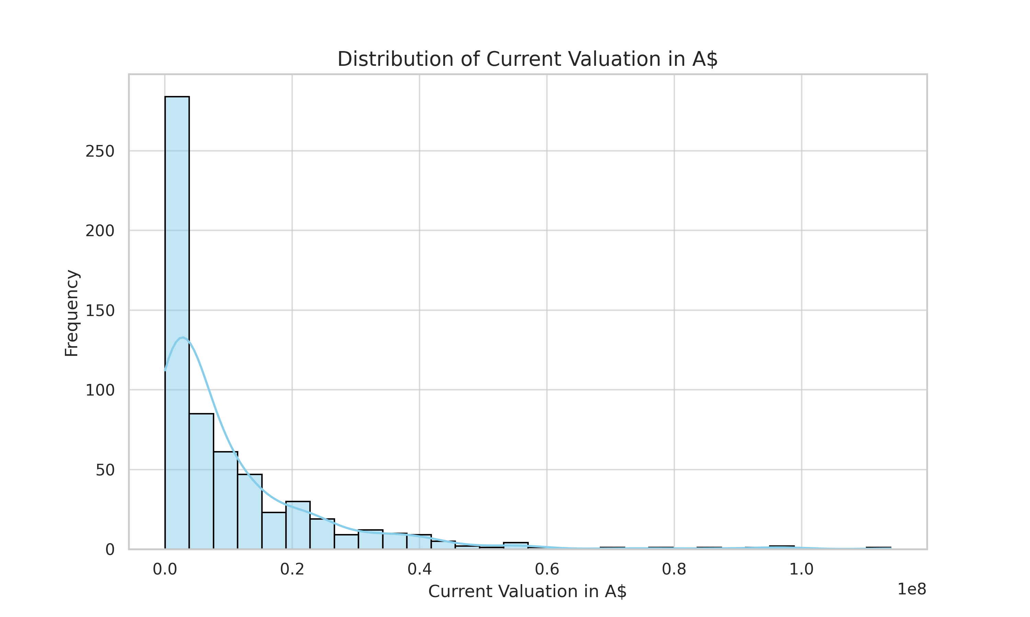
Figure 1 Distribution of Land Values
Property Area and current valuation (A$) had to be converted to numeric types for further analysis. The boxplots in Figure 2 show that the median valuation is highest for sites within 400 m of the project. This means that half of the site values within this ring had a higher valuation than the statistical median. The median valuation decreases for sites further away from the project. There are a few outliers in the data.
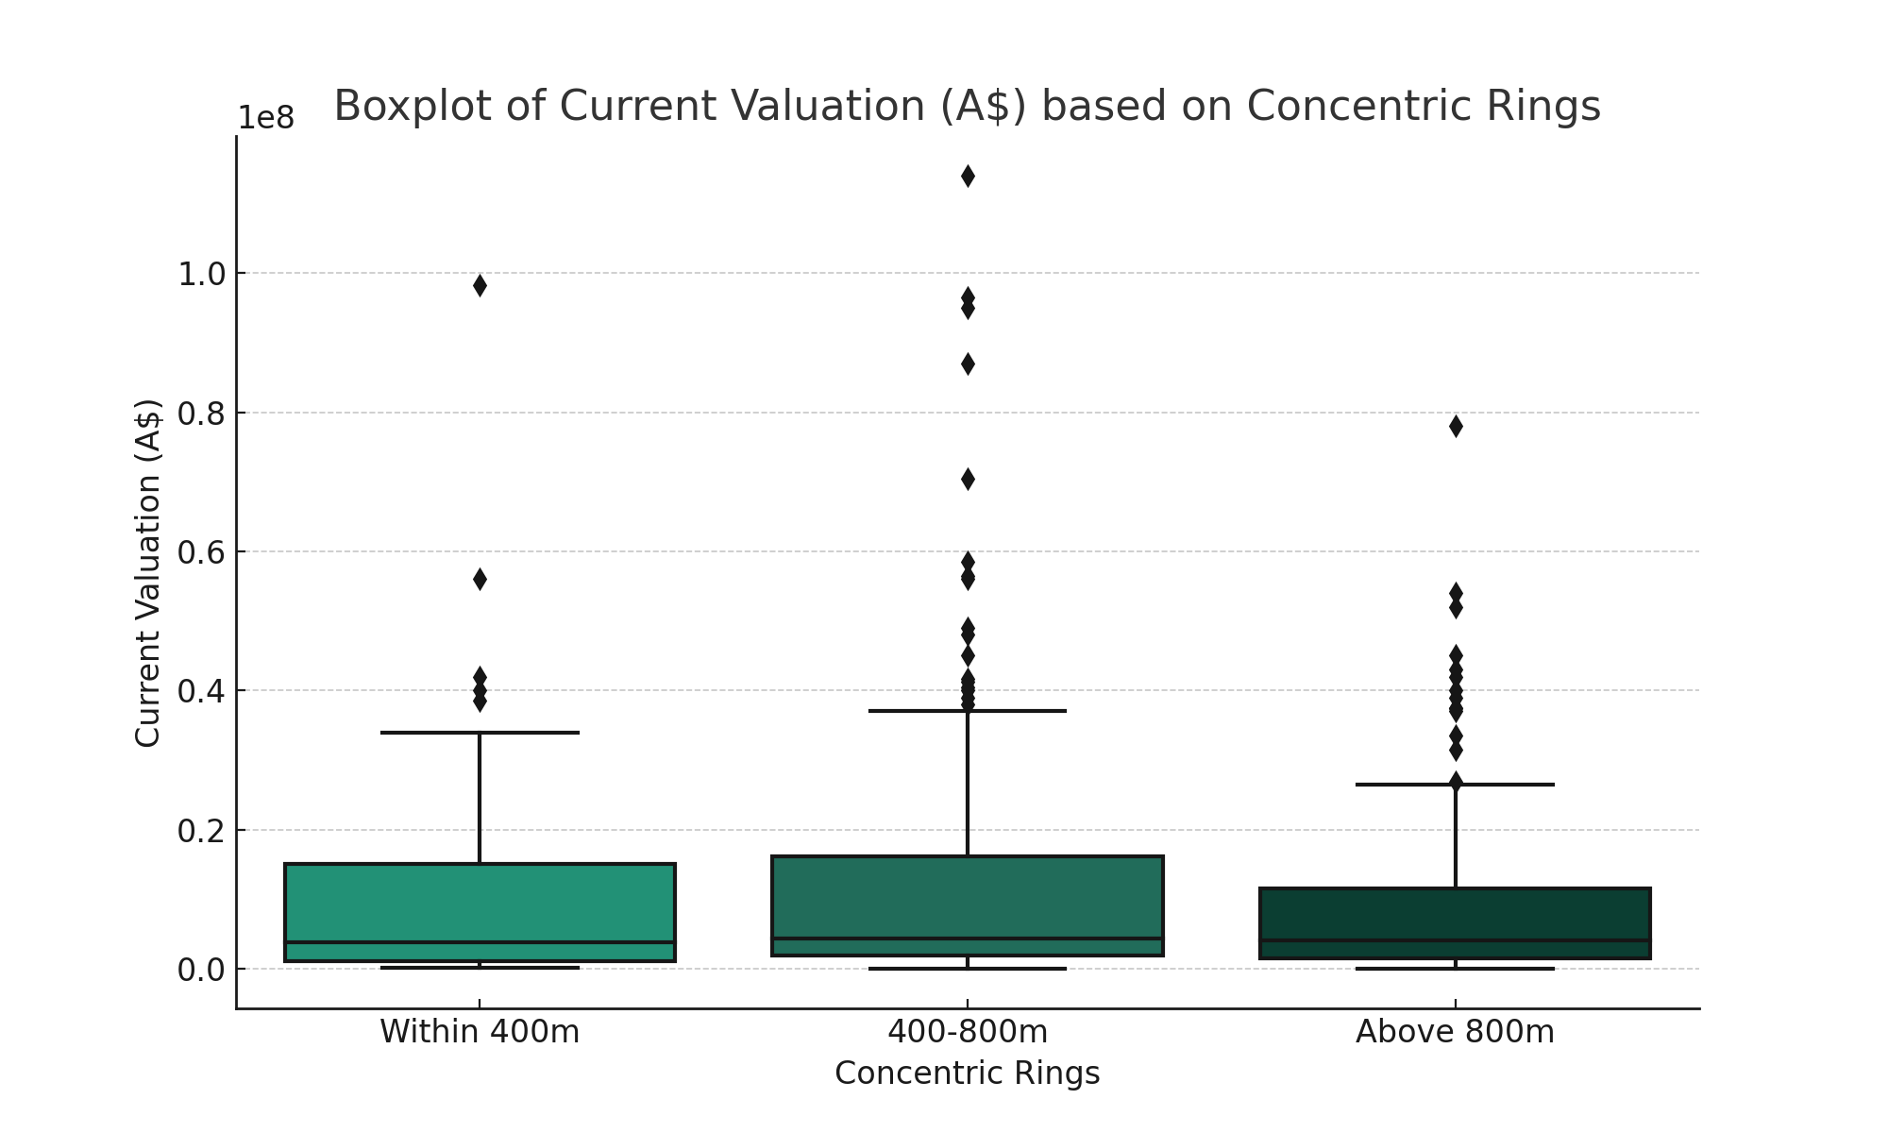
Figure 2 Valuation Boxplots for Concentric Rings

Table 2 Exploratory data analysis
Variable Name | Unit | Type | Count | Mean | Min | 25% | Median | 75% | Max
LAT | Degrees | Continuous | 616
LONG | Degrees | Continuous | 616
Current Valuation (A$) | A$ | Continuous | 616 | 10,197,166 | 10,000 | 1,500,000 | 4,200,000 | 13,050,000 | 114,000,000
Property area | M² | Continuous | 616 | 1442 | 1 | 384 | 911 | 1824 | 9395
Property ID |  | Integer | 616
Total lots | Count | Integer | 616 | 20.88 | 1 | 1 | 1 | 3 | 467
WithinPrecinct | Binary | Binary | 616
DistanceToProject | Metres | Continuous | 616 | 676.4 | 106.7 | 469.9 | 697.2 | 911.5 | 1097.1
ConcentricRings | Category | Categorical

Methodology
This study used hedonic pricing models (HPM) to test our hypotheses. The hedonic approach recognises that property values are determined by the inherent characteristics of the land as well as other external factors. Hedonic models can incorporate time dummy variables to isolate the temporal effect of new infrastructure or construction over time (Agostini and Palmucci, 2008) However, due to limited data acessability on the longitudinal nature, this could not be accounted for in the scope of this study. By measuring statistically significant changes in the coefficients of the spatial variables, we extract the intangible value transfer to the property market. In this study, the empirical HPM takes the following form.
Ln(Land Value)= β₀ + β₁Property Area + β₂WithinPrecinct + β₃Within400m + _{β4} Between400-800m+ β₅Above 800+ β₆Total Lots + ε
Where:
- Ln(Land Value): The dependent variable represents the natural log of the Current Valuation of a property.
- β0 is the intercept term representing the base value of Ln (Land Value) when all other variables are zero.
- β₁: Coefficient for Property Area, representing the change in Ln (Land Value) for a one-unit increase in property area, holding all other variables constant.
- β₂: Coefficient for the 'withinPrecinct' dummy variable. A value of 1 indicates that the property is within the Queen's Wharf precinct and 0 otherwise.
- β₃: Coefficient for properties within 400m of the megaproject, indicating the change in Ln (Land Value) for properties within this distance band.
- β₄: Coefficient for properties between 400-800m from the megaproject, indicating the change in Ln (Land Value) for properties within this distance band.
- β₅: Coefficient for properties 'Above 800m' from the megaproject, indicating the change in Ln (Land Value) for properties within this distance band.
- β₆: Coefficient for Total Lots, representing the change in Ln (Land Value) for a one-unit increase in the number of lots, holding all other variables constant.
- ε: Error term.
We used the Ordinary Least Squares (OLS) method to estimate these coefficients. Bootstrapping techniques were applied to validate the model and to ensure its robustness. Robust standard errors were clustered at the spatial level to account for correlations within distance rings. Table 4 in the Appendix lists the correlation matrix, suggesting a strong negative correlation of -0.91 between Distance to Project and Within400. To avoid multicollinearity, DistanceToProject was removed from the final regression. Normalisation was performed to bring all variables to a common scale, ensuring that no variable disproportionately influenced the model. Finally, the dependent variable was transformed using the natural logarithm to better deal with skewness in the valuation data and achieve more intuitively interpretable results.

Results
We present the empirical results of applying the hedonic regression model to the dataset. The model revealed statistically significant coefficients for key variables like 'WithinPrecinct' and distance bands ('Within 400m', 'Between 400-800m', 'Above 800m'). These results are robust to various checks and validations including bootstrapping. The model’s overall fit is statistically significant, with an F-statistic of 67.301, which is highly significant at the 1% level. Our hedonic model showed an adjusted R² of 0.350, indicating that approximately 35% of the variance in our dependent variable was explained by the set of variables. Site values with more lots were generally more valuable, as indicated by the positive coefficient of 0.115. In general, larger sites are more valuable. This aligns with the intuitive understanding that larger areas command higher prices while keeping other factors constant. A positive coefficient of 0.099 indicates that proximity to megaprojects has a positive effect on land value. This supports the hypothesis that the state capitalises on these projects through increased land value uplift in the immediate vicinity. Properties within 400 m of the project showed a 0.049 increase in logarithmically transformed valuation. The modest positive coefficient of 0.087 suggests that properties located at a moderate distance from the project benefit, albeit to a lesser extent. A modest increase of 0.087 in the logarithmic transformation valuation was observed for properties located between 400 and 800 m from the project. The model did not explain land valuations beyond 800m. This might be due to the limited effect of the project during the construction stage owing to decreased connectivity. The negative coefficient of -0.085 for properties within the precinct is counterintuitive. Properties within the precinct may be more valuable. This could imply that other factors, possibly not included in the model, affected valuations within the precinct. Being within the precinct is associated with a -0.085 decrease in the log-transformed valuation, suggesting a slightly negative impact. Table 3 presents a detailed Regression Summary of the model.
Table 3 Regression Output
Dependent Variable
Ln(Current Valuation (A$)) |  | This variable represents the value of the land, which we aim to explain.
Independent variables:
Constant | 0.000 (0.032)
Property area | 0.552*** | The size of the property is a natural factor that affects its value.
WithinPrecinct | -0.091** | A binary variable to capture whether the property is within the megaproject's precinct
Within 400 m | 0.099** | Variable to capture the concentric ring effect on valuation
Between_400_800m | 0.087** | Variable to capture the concentric ring effect on valuation
Above_800_m |  | Variable to capture the concentric ring effect on valuation
Total lots | 0.115*** | The number of lots can be a proxy for the complexity of the property.
Observations | 616
R2 | 0.356
Adjusted R2 | 0.350
Residual Std. Error | 0.806 (df = 610)
F Statistic | 67.301*** (df = 5; 610)
Note: | *p<0.1; **p<0.05;***p<0.01

FINDINGS
Building on these results, we interpret the significant coefficients in the context of our research question. The increase in land value showed a gradation based on the distance from the megaproject, aligning with our hypothesis that the impact would be concentric. A positive coefficient suggests that properties with larger areas are likely to experience greater financial returns. This could be linked to the utility and development potential of larger plots. The properties closest to the megaproject are likely to experience the most direct benefits, such as improved accessibility, better amenities, and possibly higher demand, due to the project's attractiveness. These benefits often result in the most substantial increase in land value, and the positive coefficient for this distance band should be captured. Policymakers could use this information to consider localised tax or fee structures that capitalise on this uplift. The decline in valuation beyond 800 m may indicate that the benefits of the megaproject have diminishing returns with distance. This could be due to the localised nature of certain services or amenities. These findings suggest that governments can significantly capitalise on promoting megaprojects through an increase in surrounding land values.

Discussion
This study examined financial returns to the state by promoting the development of urban megaprojects. The Hedonic Regression Model demonstrated that our study area had a significant effect on land value within our designed distance bands, thereby increasing state revenue from incremental land value taxation in addition to stimulating economic activity. Our model provides insight into the localised effects of Queen’s Wharf development on land values, aiding the understanding of unimproved site values in the presence of mixed-use megaprojects. Caution should be taken when interpreting these results, as our model is simplified to reality and the relatively low R² may indicate that not all factors affecting land values were considered in the model.
High-quality data access is a major challenge in real-estate research. This study had some limitations, such as the cross-sectional nature of the dataset. Temporal analysis using longitudinal data over time may yield better results. The study area was well-defined; however, similar projects may produce different results. Megaprojects require agglomeration effects and density, which are usually found in city centres. This brings the issue of model assumptions and omitted variable bias, as land values are usually highest in city centres.
Unlike static cross-sectional data, longitudinal data in the form of time-series or panel data analysis can uncover trends, cycles, or growth trajectories, which could pinpoint specific impacts over time and thus calculate the capitalisation period on these projects for the state involved in Public-Private Partnerships. Another benefit of time-series data would be to unravel the impact of mixed-use megaprojects in the different stages of the project lifecycle. Future research could also incorporate qualitative data from non-standardised valuation methods, such as contingent valuation, which could strengthen the discussion on public stakeholder megaproject promotion that would be far beyond the scope of this study. Ultimately, the model specification itself can be improved, such as nonlinear or semiparametric models, to increase the explanatory power of the model. Nevertheless, some valid generalisations can be made for project stakeholders involved in similar urban development projects.

Conclusion
This study finds empirical evidence that urban megaprojects such as the Queen's Wharf Development Project in Brisbane can raise land value and generate financial returns for the state. The results were validated, and the study's academic and policy contributions were reinforced. Policymakers can use these findings to optimise the land use mix and fiscal policies. This study aims to assess the financial returns to the state of urban megaprojects. A Hedonic Regression Model revealed that megaprojects increased land values within a given radius. This study supports the state's megaproject investment as a way to generate financial gains through higher land value. This could lead to more revenue through property taxes or land use, thus allowing the state to benefit from its investment. This study quantitatively evaluates megaprojects' financial returns to the state, providing useful insights for academia and policy making. However, this study had some limitations, mainly in its spatial scope and cross-sectional data. The cross-sectional nature of the data limits the ability to definitively determine causality regarding the megaproject's impact over time. Access to longitudinal data tracking land values before and after the project's commencement would strengthen the empirical analysis. There is a plethora of ways for future research to build on the findings of this study. We suggest incorporating longitudinal data to compile a panel data covering historic observations and bracketing the megaproject timeline. Further research could also apply more advanced spatial econometric techniques to model spill over effects across property transactions. This would allow stronger causal claims regarding the development's influence in the private realm. Despite the data constraints, this cross-sectional analysis provides indicative evidence of capitalisation effects around the megaproject site. The results suggest that public policymakers may benefit from the land value uplift.

Reference LisT
Agostini, C.A. and Palmucci, G.A. (2008) ‘The anticipated capitalisation effect of a new metro line on housing prices’, Fiscal Studies, 29(2), pp. 233–256. Available at: https://doi.org/10.1111/j.1475-5890.2008.00074.x.
Australian Bureau of Statistics (2023) https://www.abs.gov.au/statistics/people/population/regional-population/2021-22#capital-cities.
Banister, D. and Thurstain-Goodwin, M. (2011) ‘Quantification of the non-transport benefits resulting from rail investment’, Journal of Transport Geography, 19(2), pp. 212–223. Available at: https://doi.org/https://doi.org/10.1016/j.jtrangeo.2010.05.001.
Damayanti, R.W., Hartono, B. and Wijaya, A.R. (2021) ‘Clarifying Megaproject Complexity in Developing Countries: A Literature Review and Conceptual Study’, International Journal of Engineering Business Management [Preprint]. Available at: https://doi.org/10.1177/18479790211027414.
Flyvbjerg, B. (2014) ‘What You Should Know About Megaprojects and Why: An Overview’, Project Management Journal [Preprint]. Available at: https://doi.org/10.1002/pmj.21409.
Gibbons, S. and Machin, S. (2005) ‘Valuing rail access using transport innovations’, Journal of Urban Economics, 57(1), pp. 148–169. Available at: https://doi.org/10.1016/j.jue.2004.10.002.
Harris, M. (2016) ‘Barangaroo: Machiavellian megaproject or erosion of intent?’, in Urban Regeneration in Australia: Policies, Processes and Projects of Contemporary Urban Change. Taylor and Francis, pp. 111–134.
Harris, M. (2017) ‘Competitive Precinct Projects: The Five Consistent Criticisms of “Global” Mixed-Use Megaprojects’, Project Management Journal, 48(6), pp. 76–92. Available at: https://doi.org/10.1177/875697281704800607.
Herath, S. and Jayasekare, A.S. (2021) ‘City proximity, travel modes and house prices: the three cities in Sydney’, Journal of Housing and the Built Environment, 36(2), pp. 407–431. Available at: https://doi.org/10.1007/S10901-020-09805-W.
Hübscher, M. (2019) ‘From Megaprojects to Tourism Gentrification? The Case of Santa Cruz Verde 2030 (Canary Islands, Spain)’, Boletín De La Asociación De Geógrafos Españoles [Preprint]. Available at: https://doi.org/10.21138/bage.2813.
Khoshnoud, M., Sirmans, G.S. and Zietz, E.N. (2023) ‘The Evolution of Hedonic Pricing Models’, Journal of real estate literature, 31(1), pp. 1–47. Available at: https://doi.org/10.1080/09277544.2023.2201020.
Klingmann, A. (2022) ‘Rescripting Riyadh: How the Capital of Saudi Arabia Employs Urban Megaprojects as Catalysts to Enhance the Quality of Life Within the City’s Neighborhoods’, Journal of Place Management and Development [Preprint]. Available at: https://doi.org/10.1108/jpmd-06-2021-0062.
Lancaster, K.J. (1966) ‘A New Approach to Consumer Theory’, The Journal of political economy, 74(2), pp. 132–157. Available at: https://doi.org/10.1086/259131.
Majoor, S. (2006) ‘Conditions for multiple land use in large-scale urban projects’, Journal of Housing and the Built Environment, 21(1), pp. 15–32. Available at: https://doi.org/10.1007/s10901-005-9030-5.
McMillen, D.P. (1996) ‘One Hundred Fifty Years of Land Values in Chicago: A Nonparametric Approach’, Journal of urban economics, 40(1), pp. 100–124. Available at: https://doi.org/10.1006/juec.1996.0025.
Mevada, J. and Devkar, G. (2017) ‘Analysis of Reasons for Cost and Time Overrun in Indian Megaprojects’, Matec Web of Conferences [Preprint]. Available at: https://doi.org/10.1051/matecconf/201712002018.
Parker, J. and Simpson, G.D. (2020) ‘A Theoretical Framework for Bolstering Human-Nature Connections and Urban Resilience via Green Infrastructure’, Land [Preprint]. Available at: https://doi.org/10.3390/land9080252.
Perić, A. (2019) ‘Public Engagement Under Authoritarian Entrepreneurialism: The Belgrade Waterfront Project’, Urban Research &Amp; Practice [Preprint]. Available at: https://doi.org/10.1080/17535069.2019.1670469.
Perić, A. and D’hondt, F. (2020) ‘Squandering the Territorial Capital in the Balkans? Urban Megaprojects Between Global Trends and Local Incentives’, Urban Design International [Preprint]. Available at: https://doi.org/10.1057/s41289-020-00146-2.
Pitsis, A. et al. (2018a) ‘Megaprojects Redefined – Complexity vs Cost and Social Imperatives’, International Journal of Managing Projects in Business [Preprint]. Available at: https://doi.org/10.1108/ijmpb-07-2017-0080.
Pitsis, A. et al. (2018b) ‘Megaprojects redefined – complexity vs cost and social imperatives’, International Journal of Managing Projects in Business, 11(1), pp. 7–34. Available at: https://doi.org/10.1108/IJMPB-07-2017-0080.
Rosen, S. (1974) ‘Hedonic Prices and Implicit Markets : Product Differentiation in Pure Competition’, Journal of Political Economy, 82(1), pp. 34–55.
Santamaría, G. del C. (2019) ‘Megaprojects, Development and Competitiveness: Building the Infrastructure for Globalization and Neoliberalism’, Athens Journal of Social Sciences [Preprint]. Available at: https://doi.org/10.30958/ajss.6-4-1.
Searle, G. and Legacy, C. (2019) ‘Australian Mega Transport Business Cases: Missing Costs and Benefits’, Urban Policy and Research, 37(4), pp. 458–473. Available at: https://doi.org/10.1080/08111146.2019.1663727.
Slaughter, R.A. (2016) ‘How “development” promotes redundant visions: The case of the queen’s wharf casino project, Brisbane’, Journal of Futures Studies, 21(1), pp. 77–84. Available at: https://doi.org/10.6531/JFS.2016.21(1). E77.
Swyngedouw, E., Moulaert, F. and Arantxa, R. (2002) ‘New Geographies of Power, Exclusion and Injustice Neoliberal Urbanization in Europe : Large-Scale Urban Development Projects and the New Urban Policy’, Antipode, 34, pp. 542–577. Available at: files/1630/1467-8330.00254 (1).pdf.

Appendix
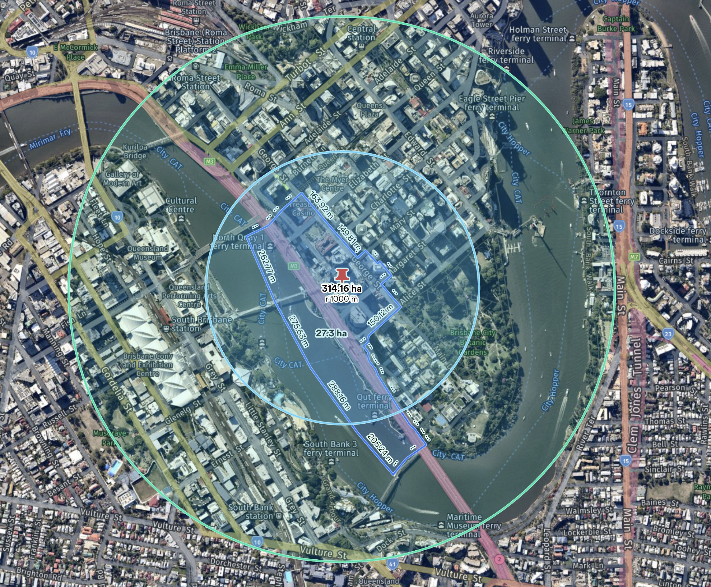
Figure 3: Aerial View of the Study Area

Table 4 Correlation Matrix | LAT | LONG | Current valuation (A$) | Property area | Valuation rate | Property Id | Total lots | Within Precinct | DistanceTo Project | Within_400m | Between_  400_800m | Above_800m
LAT | 1 | 0.3818749 | 0.094334 | -0.067759 | -0.03011 | -0.277613 | -0.077165 | -0.056666 | -0.054998 | -0.034967 | 0.182728 | -0.15768
LONG | 0.3818749 | 1 | 0.1994336 | 0.0718305 | 0.0103762 | -0.12302 | -0.01045 | 0.077118 | -0.463202 | 0.2275594 | 0.2993559 | -0.475891
Current valuation (A$) | 0.0943341 | 0.1994336 | 1 | 0.5591153 | 0.0557903 | 0.0792432 | 0.1233332 | 0.0083073 | -0.082094 | 0.0140888 | 0.09854 | -0.110196
Property area | -0.067759 | 0.0718305 | 0.5591153 | 1 | -0.036298 | 0.2048272 | 0.2150959 | 0.0470687 | -0.012692 | -0.065895 | 0.0916979 | -0.042197
Valuation rate | -0.03011 | 0.0103762 | 0.0557903 | -0.036298 | 1 | 0.024434 | -0.010825 | -0.012547 | -0.042196 | -0.017477 | 0.0526312 | -0.039813
Property Id | -0.277613 | -0.12302 | 0.0792432 | 0.2048272 | 0.024434 | 1 | 0.197838 | 0.144264 | -0.01722 | 0.065619 | -0.11288 | 0.063782
Total lots | -0.077165 | -0.01045 | 0.1233332 | 0.2150959 | -0.010825 | 0.197838 | 1 | -0.03093 | -0.019965 | 0.0306626 | -0.04742 | 0.0244321
WithinPrecinct | -0.056666 | 0.077118 | 0.0083073 | 0.0470687 | -0.012547 | 0.1442642 | -0.03093 | 1 | -0.378511 | 0.4270084 | -0.166667 | -0.157987
DistanceToProject | -0.054998 | -0.463202 | -0.082094 | -0.012692 | -0.042196 | -0.01722 | -0.019965 | -0.378511 | 1 | -0.716153 | -0.276051 | 0.825582
Within400 | -0.034967 | 0.2275593 | 0.0140888 | -0.065895 | -0.017477 | 0.065619 | 0.0306626 | 0.4270084 | -0.716153 | 1 | -0.390312 | -0.369985
Between400-800 | 0.182728 | 0.2993559 | 0.09854 | 0.0916979 | 0.0526312 | -0.11288 | -0.04742 | -0.166667 | -0.276051 | -0.390312 | 1 | -0.710939
Above800 | -0.157677 | -0.475891 | -0.110196 | -0.042197 | -0.039813 | 0.063782 | 0.0244321 | -0.157987 | 0.825582 | -0.369985 | -0.710939 | 1

