post-conflict infrastructure development in sri lanka: A swot analysis

LEBUNU HEWAGE UDARA WILLHELM ABEYDEERA and

WADU MESTHRIGE JAYANTHA

[S3855817@student.rmit.edu.au*](mailto:S3855817@student.rmit.edu.au*) and wadu.jayantha@rmit.edu.au

RMIT UNIVERSITY, MELBOURNE

# Abstract

Sri Lanka confronts numerous challenges following an egregious conflict that caused significant challenges in infrastructure development. This study examined the strengths, weaknesses, opportunities, and threats of post-conflict infrastructure development in Sri Lanka using project data from the irrigation and land, port, aviation and transport, regional development, roads, and water sectors. A qualitative approach was used for this study, and findings revealed the availability of contractors` own resources and the use of special technologies as major strengths whilst unfamiliarity with social factors and poor identification of environment as major weaknesses. The identified opportunities include the availability of resources at a low cost, the availability of funding sources. The study also revealed a shortage of resources, language barriers, the risk of violence, and attitude issues among people as major threats. These findings may be useful for other conflict-affected countries to build their capacity to overcome challenges and find better solutions.

**Keywords:** Sri Lanka, infrastructure development, strength, weaknesses, post-conflict.

**INTRODUCTION**

The concept of post-conflict development, as articulated by the World Bank, encompasses the process of reconstructing the socio-economic framework of a society and fostering the necessary circumstances for sustainable peace (Lokuhetty et al., 2013). This includes the imperative inclusion of effective governance and the establishment of a robust legal system as integral elements. The objective of post-conflict redevelopment is to address the physical devastation caused by war, with a particular focus on rebuilding devastated structures, sites, and historical town centres (Garstka, 2010). Following a conflict, nations must undergo a process of comprehensive recovery that encompasses social and economic rehabilitation as well as the physical reconstruction of affected areas. In his study, Arthur (2011) examined the use of infrastructure development in Africa as a means to establish peace and security within post-conflict and fragile contexts throughout the reconstruction phase in Africa. As stated by Sserwanga et al. (2014), the Ugandan government has acknowledged the necessity of providing basic healthcare, education, water and sanitation, and social protection in the post-conflict period. Hence, it is apparent that the development of infrastructure plays a significant role in the post-conflict period in a country.

The process of transitioning from a state of conflict to a post-conflict environment presents significant challenges (Lynch et al., 2013). During this transition, both society and the economy undergo a shift from a state of complete breakdown, where public and international institutions strive to provide social protection, to a phase of reconfiguration. Particularly in the context of developing countries, this issue has considerable importance due to the difficulties they encounter in effectively planning and controlling their surroundings to acquire the necessary resources for meeting the subsistence requirements of their populace, all while contending with conflict situations. A study conducted by Lynch et al. (2013) examined the conflict dynamics in Freetown, Sierra Leone which revealed the significant difficulties encountered during the rebuilding phase after the conflict. This was further affirmed by Sserwanga et al. (2014) who argued that post-conflict societies encounter significant challenges in terms of accessing and effectively using the necessary resources for their rehabilitation. However, King and Samii (2014) suggest that challenges might potentially lead to positive outcomes, as they create a chance for institutions to be reconstructed. The process of post-conflict rebuilding mostly entails addressing institutional complexities (Schiavo-Campo, 2003). The key difficulty lies in effectively managing the delicate equilibrium between immediate reconstruction requirements and the long-term growth of institutions. For instance, the substantial assistance provided by donors played a beneficial role in the restoration and recovery of the Gulu district in northern Uganda following the conflict with the Lord's Resistance Army (LRA) (Sserwanga et al., 2014). As stated by Lacher (2007), in the aftermath of the conflict in Iraq, the Iraqi population faced the difficulty of being abandoned by the United States Agency for International Development (USAID). Nevertheless, it is plausible for Iraqis to independently execute rehabilitation initiatives with minimal or no assistance from foreign contractors on the ground. Infrastructure development plays a pivotal role in post-conflict contexts, as it is a critical determinant of long-term stability and socio-economic progress. However, the process of infrastructure development in such scenarios is fraught with significant challenges and threats. Along with the challenges, a vast array of opportunities is also likely to appear during the post conflict rebuilding process which needs to be recognized and grabbed. Therefore, conducting a study to explore the strengths, weaknesses, opportunities and threats associated with post-conflict infrastructure development will be beneficial for any country recovering from a conflict to optimize their rebuilding process effectively. Proactively addressing the challenges and threats will reduce unnecessary costs while recognizing the opportunities and strengths will optimize the development process.

Sri Lanka marked the end of a 26-year conflict in 2009, which particularly affected the country's north and east (Lokuhetty et al., 2013). As a result, following 2009, rebuilding the north and east regions became a major part of the conflict recovery process. Similar to many other countries, the rebuilding process has been challenging for a number of reasons, which include financial, legal, and resource-related issues (Lokuhetty et al., 2013). The Sri Lankan government had to strengthen its capacities and prepare to accept the disparity of the challenging environment in order to overcome the issues and carry out the developments during the post-conflict period. Identifying the strengths, weaknesses, opportunities, and threats associated with infrastructure development is a critical aspect to achieve the expected development goals. With numerous construction and infrastructure development projects still being undertaken following the conflict, this study aims to conduct a thorough analysis of the strengths, weaknesses, opportunities and threats associated with these developments. The scope of the research is constrained to studying infrastructure development projects in accordance with the research topic. Since the research is centred on a post-conflict scenario, it only encounters infrastructure development projects that have been carried out in conflict-affected areas, particularly in the Northern and Eastern Provinces. The study's focus is also restricted to the areas of irrigation and land use, ports, aviation and transportation, regional development, roads, and water, which were determined to be the most highly developed areas of post-conflict infrastructure development.

**LITERATURE REVIEW**

Post-conflict development is a key part of the damage recovery process in a country. Therefore, the post-conflict phase is both demanding and productive for a country that has experienced conflict. In order to attain stable economic conditions and persistent peace, these countries set up programs during the post-conflict period. One of the urgent demands is the rehabilitation and reconstruction of infrastructure, which is regarded as one of the most important economic indicators that maintains a country's economic power and riches in order to raise the standard of living for its population (Sampat Wakchaure and Neeraj Jha, 2011).

**Impact of conflict in Sri Lanka**

The protracted conflict that spanned over a period of thirty years in Sri Lanka was ultimately concluded in May 2009. The protracted civil conflict has had a detrimental impact on the entire nation, with a particular emphasis on the North and East Provinces. **Figure 1** depicts the geographical region of Sri Lanka that has been severely impacted by the war. The protracted conflict has had a significant impact on individuals, families, and communities, resulting in numerous displacements and the loss of familial, social, and economic connections, as well as homes, employment, and other valuable resources (Somasundaram and Sivayokan, 2013). The societal impact of the battle was significant, resulting in a reported total of over 100,000 fatalities and injuries (Somasundaram and Sivayokan, 2013). Furthermore, the conflict resulted in the psychological and physical displacement of the populace, both within the borders of the nation and beyond, while also causing significant harm to towns, infrastructure, and the natural environment. As indicated by Keerawella (2013), the prevailing violence within the country has resulted in significant damage to infrastructure and has had a detrimental impact due to the disregard of basic maintenance. Ultimately, it had an impact on the quality of 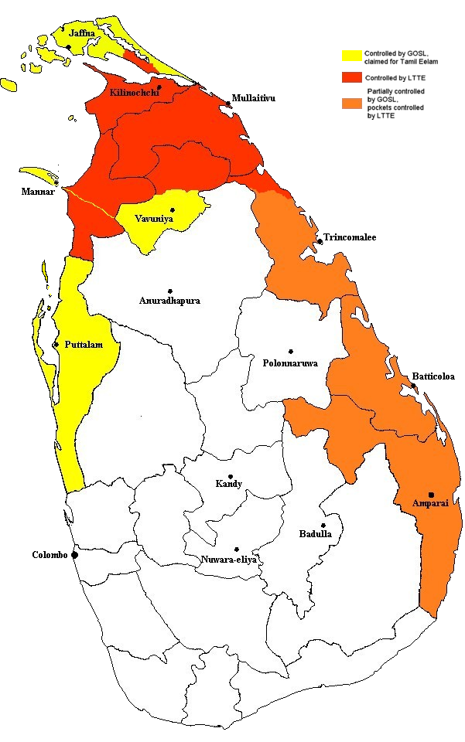life for individuals who have returned to their home country.

Figure 1: Regions of Sri Lanka severely affected by the civil conflict.

Apart from the humanitarian effects, there has been a significant impact to the Sri Lankan economy due to the conflict. Especially the major devastation caused to the economic hubs such as the Central Bank of Sri Lanka and the international airport, caused a significant setback to the Sri Lankan economy. This was affirmed by the study conducted by Höglund and Orjuela (2011) which revealed the negative consequences of the civil conflict on the Sri Lankan economy. Despite Sri Lanka experiencing an average growth rate of 5% between 1995 and 2008, uneven regional distribution of the country's economic progress caused a significant impact on the quality of life experienced by the Sri Lankans during the conflict period (Höglund and Orjuela, 2011). The major deficiencies of foreign investments in the country, lack of tourist arrivals which inflicted a lower income from the tourism sector and most significantly the heavy portion allocated for military developments caused heavy dents to the Sri Lankan economy (Keerawella, 2013). While the western Province, encompassing the capital city of Colombo, has been identified as the region exhibiting the highest level of economic prosperity within the country, the northern and eastern provinces have been documented as the areas characterized by the lowest economic conditions on the island (Höglund and Orjuela, 2011). This can be attributed to the extensive damage inflicted by the war and the insufficient levels of investment in these regions. Moreover, conflict had severe impacts on other facilities such as water and electricity in the conflict affected regions which has impacts on economy as well as the well-being of the occupants of the region. The study conducted by Taira et al. (2010) revealed that there was a 46% drop in the electricity supply and a 11% drop in the water supply as shown in **figure 2**. Disruptions to major infrastructure facilities such as electricity and water is a clear indication of the negative impacts of a conflict. The negative impacts of the conflict haunted the Sri Lankan economy for a long period and overcoming those issues require major developments, not only in the commercial capital Colombo, but also in the northern and eastern regions. Infrastructure development is the ideal first step in reconstructing a region, helping the people to restore the normal life and thereby strengthening the economy.

**Post-conflict infrastructure development in Sri Lanka**

Figure 2: The impact on water and electricity supply in the conflict affected areas.

The conclusion of the prolonged civil conflict in Sri Lanka has created numerous opportunities for the implementation of extensive development initiatives in post-conflict regions. The percentage of GDP allocated for military improvements decreased from 3.9 percent in 2009 to 3.1 percent in 2011 which resulted in a potential for the reallocation of resources into endeavours focused on rehabilitation and reconstruction (Ministry of Finance, 2011). Therefore, the reduction in defence spending enables a rise in development investment, reaching 6 percent of GDP, which include enhancements to infrastructural facilities. As indicated in the Annual Report of the Ministry of Finance and Planning: Sri Lanka (2013), the government allocated a total of Rs. 49.4 billion in 2013 on infrastructure development initiatives in the Northern Province. In these endeavours, the government has successfully secured financial assistance from several inter-governmental donors (Höglund and Orjuela, 2011). Approximately 64 percent of the funds allocated for the development of the Northern Province have been acquired from international sources. China has significantly contributed to the post-war reconstruction and development in Sri Lanka, assuming a crucial role among international donors due to its influential status as a prominent Asian nation.

The majority of post-conflict restoration efforts are concentrated on roads and bridges out of all physical infrastructure requirements (Keerawella, 2013). As reported by the Central Bank of Sri Lanka (CBSL) in 2014, many initiatives were undertaken to enhance the state of road infrastructure in regions impacted by violence. These initiatives include the Northern Road Rehabilitation Project (NRRP), the violence impacted Region Emergency Project (CAREP), and the Northern Road Connectivity Project (NRCP). The Oddusudan-Nedunkerny road, Mullaitivu-Puliyankulam road, and Nawathkuli-Karativ-Mannar highway were officially inaugurated in 2014 as part of the Northern Road Rehabilitation Programme (NRRP). Additionally, the Mankulam to Vellankulam road was successfully constructed in 2014 as part of the Community Access and Rural Empowerment Project (CAREP). As stated by Keerawella (2013), a total of 11 big bridges with a combined length of 2,538 metres were constructed in the North and East regions between 2009 and 2013. The A-9 road underwent redevelopment at a total cost of Rs. 710 million, with financial assistance provided by the Asian Development Bank. The anticipated cost of the Vavuniya-Horowpathana road was Rs. 380 million, while the cost of the Medawachchiya-Mannar route amounted to Rs. 360 million. Thus, it is evident that a large number of infrastructure projects are being undertaken in the northern and eastern regions of Sri Lanka as a part of the post conflict development. It is essential to recognize the importance of these infrastructure development projects to a post-conflict society.

**Importance of post-conflict infrastructure development**

Agrawal (2020) emphasized how closely a nation's level of progress in its physical and social infrastructure is related to its level of social and economic development. Agrawal (2020) provided additional evidence to support the notion that physical infrastructure significantly contributes to the enhancement of a country's productivity and facilitates the identification of the latent capabilities of its human capital by establishing conducive environments for optimal performance. The presence of economic instability often leads to a resurgence of violations, making it crucial to prioritize economic stability and rapid reconstruction in areas affected by war in order to prevent conflicts (Höglund and Orjuela, 2011). It is essential for conflict-affected nations to establish a framework that promotes a competent approach, enabling international actors to effectively implement economic development initiatives (Chin, 2019). As stated by Schiavo-Campo (2003), the Word Bank effectively contributes to post-conflict rehabilitation by offering timely assistance through trust funds, financial support, and new approaches when necessary. In addition to this, the World Bank plays a role in supporting recipient governments and local partners in their efforts to contribute to post-conflict rebuilding.

Providing desperately required physical infrastructure facilities is a smart place to commence post-conflict reconstruction (Sserwanga et al., 2014). Damages to the nation's physical infrastructure, such as those to the communication network and public utilities, will make it more difficult to end the fight and establish peace (Earnest, 2011). Reconstruction and repair of infrastructure damaged by a conflict prevents the chances of a conflict re-occurrence (Sserwanga et al., 2014). Furthermore, Earnest (2011) found that the process of national reconciliation is aided by the early restoration of social, health, and educational services because they are vital to raising people's standards of life. Investments in societal and physical infrastructure, as stated by Nataraj (2007), have a favourable direct and indirect impact on the disadvantaged. Therefore, infrastructure development is crucial for both economic growth and the eradication of poverty in order to raise people's quality of living. The implementation of infrastructure development programmes in post-conflict settings can provide crucial assistance for the sustainability of local contractors (Djip, 2014). Earnest (2011) asserts that the introduction of post-conflict infrastructure development facilitates the engagement of highly qualified and professional individuals in the processes of reconciliation and reconstruction, hence enhancing the likelihood of achieving enduring peace. Schultze-Kraft and Rew (2014) have identified urgent housing, rural area rehabilitation, and refugee repatriation programmes as the most crucial needs during the post-conflict revival phase. It is imperative to contemplate the integration of post-conflict reconstruction and economic rehabilitation. Due to the exigencies and prospects associated with post-conflict infrastructure development, countries that have emerged from conflicts have formulated development strategies aimed at optimising the benefits accrued over an extended duration. Nevertheless, it is a formidable undertaking to endure such a delicate predicament, since countries are compelled to withstand the challenges imposed by the conflict.

**RESEARCH METHODOLOGY**

Given the exploratory nature of this study and its alignment with the research question "What are the strengths, weaknesses, opportunities, and threats of post-conflict infrastructure development in Sri Lanka?", a qualitative research technique was adopted. Data pertaining to infrastructure development projects implemented in conflict-affected regions during the post-conflict era in Sri Lanka were acquired by a comprehensive examination of relevant documents. The data pertaining to strengths, weaknesses, opportunities, and threats was collected through semi-structured interviews conducted with professionals actively engaged in post-conflict infrastructure construction projects. This study is grounded based on the actual experiences of construction professionals engaged in post-conflict infrastructure development initiatives. Therefore, individuals employed in construction and consultancy firms specialising in Irrigation & Land, Port, and Aviation & Transport, Regional Development, Roads, and Water sectors were chosen to participate in semi-structured interviews. The interview guideline contained two main sections: the first part to gather information on the involvement of post-conflict infrastructure development projects, and the second section to gather information for carrying out the SWOT analysis. The second half of the study was further separated into six distinct areas, specifically resources and facilities, financial variables, laws, incentives, strategies, and other factors. This division was made to ensure that each issue related to post-conflict infrastructure development could be comprehensively addressed in an individual manner. The data obtained from the document review was analysed according to different sectors to determine the sectors that had substantial development in the aftermath of the conflict in Sri Lanka. Moreover, it included a comprehensive analysis of infrastructure development in a post-conflict setting, focusing on different sectors. This analysis considered the number of projects implemented and the associated costs within each sector. The research was conducted in four stages as indicated in **figure 3**.

Figure 3: The four stages of the research process

Formulating a fundamental framework to identify the key factors of SWOT analysis.

Acquiring data from literature synthesis and online resources

Conducting the SWOT analysis (semi structured interviews)

Opportunities (O)

Threats (T)

Weaknesses

Strengths (S)

Discussing the findings

Stage 1

Stage 2

Stage 3

Stage 4

**RESEARCH FINDINGS**

The initial document review provided a sector-by-sector analysis of infrastructure development in conflict-affected areas from 2009 onwards and to identify the infrastructure sectors in post-conflict Sri Lanka that have substantially advanced. The information was collected from the databases of the National Planning Department of the Sri Lankan Ministry of Finance and Planning. Based on the data presented in **figure 4**, it can be observed that the sectors of 'Irrigation and Land', 'Port, Aviation & Transport', 'Power & Energy', and 'Regional Development' have undertaken the highest number of projects, with each sector having completed a total of 12 projects. Additionally, there were a total of 10 projects documented under the 'Roads' sector, while the 'Water' sector accounted for 9 projects. The aforementioned sectors exhibit a greater quantity of initiatives in comparison to all other sectors.

Figure 4: Number of construction projects carried out in each sector.

Figure 5: Costs associated with each sector.

The document review was further used to analyse the costs associated with different construction projects. As seen in **figure 5**, the sector that incurred most significant expenditure was the "Roads" sector, which also ranks as the second highest in terms of the number of projects. 'Port, Aviation & Transport' was documented as the second most financially significant sector. The sectors of 'Power & Energy', 'Water', and 'Regional Development' were identified as the subsequent sectors with notable costs. While the 'Irrigation & Land' sector witnessed a significant number of projects, it is important to note that these projects might be classified as modest development initiatives due to their relatively low cost. The sector of 'Culture, Religion, and National Integration' has experienced higher expenditures compared to the 'Irrigation and Land' sector, despite a significantly lower number of projects implemented within the former. Based on the data provided by the sources 'Irrigation and Land', 'Port, Aviation & Transport', 'Power & Energy', 'Regional Development', Roads, and Water sectors may be highlighted as notable areas of progress in post-conflict infrastructure development between 2009 and 2015 in Sri Lanka.

The data collected through the semi-structured interviews were analysed to identify the Strengths, Weaknesses, Opportunities, Threats (SWOT) associated with the infrastructure development in Northern region in Sri Lanka. **Figure 6** contains the major points identified through the SWOT analysis. The study examined the strengths and opportunities in post-conflict infrastructure development, which is a fresh contribution compared to the existing literature synthesis. The aforementioned qualities encompass the presence of proprietary resources and contractor facilities, use of specialised technology and techniques, and the resulting benefits of company expansion and enhanced expertise. The major opportunities identified encompass several key factors, namely the abundant availability of certain materials at a cost-effective rate within the region, the accessibility of diverse funding sources and loan facilities, and the supportive measures implemented by the government, such as enabling smaller contractors to participate in large-scale projects. Additionally, the assistance provided by local authorities and the general public further contributes to the favourable conditions for potential development. Availability of materials in the region was one of the most stated opportunities by the respondents (herein after the respondents will be referred as R1, R2, R3 etc…). For instance, R3 and R12 have stated that bare lands in the northern and eastern regions consisted of earth materials required for construction. R2 further affirmed that construction materials are available within a 30km radius which will also reduce the transportation costs. R1, R2, R3, R6, R10 and R12 have also provided statements on material availability in the war affected regions that would be a major strength for construction projects. Availability of funding was ranked next in the list after material related opportunities. While R1 stated that the government-initiated credit line would aid the construction projects, R2 indicated that financing would be further aided by the countries willing to support the development process in Sri Lanka.

The research findings corroborated the existing literature findings, while also uncovering further problems. Based on the research findings, a significant number of weaknesses and threats arise because of the industry's limited capacity. R2 and R5 stated that construction industry is limited by the inexperienced staff and the limited work experience in the war affected regions. R3 and R13 have also provided evidence on the pertaining threats due to the limited capacity of the construction professionals and companies in carrying out the construction projects in northern and eastern regions. R2 and R8 also indicated that finding lower-level professionals such as technical officers and supervisors remains a significant issue in the northern and eastern based construction projects. Language barrier and cultural differences have further limited the construction companies from optimizing construction projects. These findings are in line with the findings of similar studies. For example, the study conducted by Sserwanga et al. (2014) identified insufficient industrial capacity as a significant challenge in the context of post-conflict infrastructure development. The study conducted by Wen and Char (2011) examined the post-conflict infrastructure development in Rwanda and highlights the significant challenge of resource scarcity, particularly in terms of personnel. This conclusion aligns with the observations made in the Sri Lankan context as shown by the study. Abuzayan et al. (2014) have addressed the issue of low productivity among construction workers in an uncertain environment as a significant obstacle. A comparable discovery has been made in the context of Sri Lanka, indicating that the productivity of workers has been hindered by a lack of industrial knowledge.

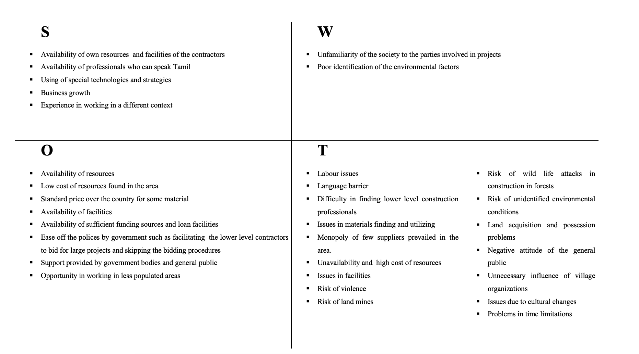

Figure 6: SWOT Analysis results

The study conducted by Gates et al. (2014) highlights the potential risks associated with government engagement in policy creation and legislation in post-conflict infrastructure development. Based on the findings of this study, it is observed that within the specific context of Sri Lanka, the active participation of the government in policy creation has facilitated opportunities for various stakeholders engaged in post-conflict infrastructure building initiatives. R13 for instance indicated that local authorities, Sri Lankan forces and government authorities actively supported the construction activities which was further affirmed by R3, R7 and R14. The government has positively intervened the construction development process which motivated the contractors and other construction professionals engaged. The study conducted by Abuzayan et al. (2014) revealed many obstacles encountered in post-conflict development, including the necessity to reassess the standard of existing structures, deficiencies in system dimension quality, and limited trustworthiness of accessible data. However, the emphasis on this aspect is not prominent within the Sri Lankan setting. Vitalis Pemunta (2012) has underlined the unsustainable nature of short-term finance cycles required for the establishment of first stages of reconstruction projects as a significant challenge faced by Sierra Leone. Nevertheless, it is important to note that in the specific context of Sri Lanka, finance issues were not a major concern due to the significant support supplied by several countries and organisations shortly after the conflict. However, this research study has shown several additional challenges, including decreased worker retention, language obstacles, intense rivalry for resources, limited supplier options, cultural considerations, the risk of land mines, complications related to land acquisition and ownership, and time constraints. The majority of these threats are hypothetical variables that may arise in any future conflict. Therefore, other nations that emerge from wars might utilise this study to enhance their ability to address obstacles, harness available resources, and eventually devise more effective solutions for the issues encountered during post-conflict infrastructure development.

**CONCLUSION**

This study offers valuable insights into the process of infrastructure development in post-conflict contexts. In the Sri Lankan context, the sectors of Irrigation & Land, Port, Aviation & Transport, Regional Development, Roads, and Water have been identified as the most prominently developed areas in the post-conflict infrastructure development. By identifying the sectors that have had considerable development in a post-conflict situation, future post-conflict countries can get an understanding of the fundamental requirements throughout the post-conflict period. Therefore, this approach facilitates the decision-making process regarding the prioritisation of urgent development requirements following a conflict. The present study elucidates the many aspects pertaining to post-conflict infrastructure development in the specific context of Sri Lanka, encompassing an analysis of its strengths, shortcomings, possibilities, and risks. The aforementioned variables possess the capacity to manifest in any other nation. Therefore, governments of other nations that emerge from conflicts, as well as the parties involved in the construction industry, can utilise this analysis to enhance their ability to address challenges, harness available benefits, and ultimately devise more effective solutions for the issues encountered during post-conflict infrastructure development.

Based on the findings of the study, it can be posited that most of the identified deficiencies may be attributed to a lack of familiarity with the specific characteristics of the environment, which were influenced by a recently concluded period of hostility. Therefore, this issue can be solved by the implementation of measures aimed at conducting comprehensive research and acquiring knowledge about the region by the stakeholders engaged in post-conflict infrastructure development, prior to proceeding with the actual development endeavours in the area. Most of the issues that were found pose a significant danger to the development of infrastructure in post-conflict settings. Therefore, it is imperative for parties engaged in post-conflict infrastructure development to possess a comprehensive idea about the aforementioned concerns. Consequently, individuals can proactively prepare themselves to acknowledge and address the potential consequences before transitioning into this setting. In order to enhance comprehension of the region, regulatory entities with jurisdiction might organise educational initiatives and workshops targeting stakeholders involved in post-conflict infrastructure building endeavours. Contractors with the capability to undertake post-conflict infrastructure development projects may be chosen, and regular awareness programmes and workshops can be organised to provide guidance on navigating the challenges and opportunities associated with engaging in such projects.

**REFERENCES**

ABUZAYAN, K. M., WHYTE, A. & BELL, J. 2014. Asset-management framework (s) for infrastructure facilities in adverse (post-conflict/disaster-zone/high-alert) conditions. *Procedia Economics and Finance,* 18**,** 304-311.

AGRAWAL, R. 2020. Review of infrastructure development and its financing in India. *Paradigm,* 24**,** 109-126.

ARTHUR, P. 2011. Capacity development and reconstruction in post‐conflict African environments. *World Journal of Entrepreneurship, Management and Sustainable Development,* 7**,** 267-306.

CHIN, W. 2019. Technology, war and the state: past, present and future. *International Affairs,* 95**,** 765-783.

DJIP, V. 2014. Entrepreneurship and SME development in post-conflict societies: The case of Bosnia & Herzegovina. *Journal of Entrepreneurship and Public Policy,* 3**,** 254-274.

EARNEST, J. 2011. *Post-conflict reconstruction: The complexity and challenges of planning and implementing infrastructure projects in Kosovo.* Curtin University.

GARSTKA, G. J. 2010. Post-conflict urban planning: The regularization process of an informal neighborhood in Kosova/o. *Habitat international,* 34**,** 86-95.

GATES, S., HEGRE, H., NYGÅRD, H. M. & STRAND, H. 2014. Development Consequences of Internal Armed Conflict. *Conflict Trends,* 3.

HÖGLUND, K. & ORJUELA, C. 2011. Winning the peace: conflict prevention after a victor's peace in Sri Lanka. *Contemporary Social Science,* 6**,** 19-37.

KEERAWELLA, G. 2013. Post-war Sri Lanka: is peace a hostage of the military victory?: dilemmas of reconciliation, ethnic cohesion, and peace-building. *(No Title)*.

KING, E. & SAMII, C. 2014. Fast-track institution building in conflict-affected countries? Insights from recent field experiments. *World Development,* 64**,** 740-754.

LACHER, W. 2007. Iraq: Exception to, or Epitome of Contemporary Post-conflict Reconstruction? *International Peacekeeping,* 14**,** 237-250.

LOKUHETTY, A., JAYAWARDENA, C. & MUDADENIYA, D. 2013. Developing a shared vision for tourism in post-war Sri Lanka. *Worldwide Hospitality and Tourism Themes,* 5**,** 486-494.

LYNCH, K., MACONACHIE, R., BINNS, T., TENGBE, P. & BANGURA, K. 2013. Meeting the urban challenge? Urban agriculture and food security in post-conflict Freetown, Sierra Leone. *Applied Geography,* 36**,** 31-39.

NATARAJ, G. 2007. Infrastructure challenges in South Asia: The role of public-private partnerships. ADBI Discussion paper.

SAMPAT WAKCHAURE, S. & NEERAJ JHA, K. 2011. Modeling of post‐construction failure factors of bridges. *Journal of Advances in Management Research,* 8**,** 246-262.

SCHIAVO-CAMPO, S. 2003. *Financing and aid management arrangements in post-conflict situations*, Conflict Prevention and Reconstruction Unit, World Bank.

SCHULTZE-KRAFT, M. & REW, M. 2014. How Does State Fragility Affect Rural Development?

SOMASUNDARAM, D. & SIVAYOKAN, S. 2013. Rebuilding community resilience in a post-war context: developing insight and recommendations-a qualitative study in Northern Sri Lanka. *International journal of mental health systems,* 7**,** 1-25.

SSERWANGA, A., KICONCO, R. I., NYSTRAND, M. & MINDRA, R. 2014. Social entrepreneurship and post conflict recovery in Uganda. *Journal of Enterprising Communities: People and Places in the Global Economy,* 8**,** 300-317.

TAIRA, B. R., CHERIAN, M. N., YAKANDAWALA, H., KESAVAN, R., SAMARAGE, S. & DESILVA, M. 2010. Survey of emergency and surgical capacity in the conflict-affected regions of Sri Lanka. *World journal of surgery,* 34**,** 428-432.

VITALIS PEMUNTA, N. 2012. Neoliberal peace and the development deficit in post‐conflict Sierra Leone. *International Journal of Development Issues,* 11**,** 192-207.

WEN, L. S. & CHAR, D. M. 2011. Existing infrastructure for the delivery of emergency care in post-conflict Rwanda: an initial descriptive study. *African Journal of Emergency Medicine,* 1**,** 57-61.